**SHOKITE VEHICLE RENTAL**

By

Hema Kothari

Mounika Donepudi

Rishikesh Reddy Maddi

University of New Haven

SPRINT II DOCUMENTATION

TABLE OF CONTENTS

1. VISION STATEMENT 4

1.1 Vision 4

1.2 Target Users 4

1.3 Project Objectives 4

1.4 Product Measure for Competition 5

1.5 Future Enhancements 6

2. PRODUCT BACKLOG 7

2.1 Sprint II Plan 7

2.2 Key Features of High Risk Use Cases 9

2.3 Key non-functional requirements 9

2.4 High Level Use Cases for Core System 9

3. UML 11

3.1 Fully Dressed Use Cases 11

3.2 CLASS DIAGRAM 39

3.3 INTERACTION DIAGRAMS 40

3.4 STATE DIAGRAM 46

3.5 SERVICE ORIENTED ARCHITECTURE 48

3.6 GRASP 49

3.7 GoF PATTERNS- Factory pattern 50

4. USER INTERFACE AND FUNCTIONS 51

5. USER GUIDE 51

6. PROGRAM 53

6.1 Program Code (Java) 53

6.2 Javadoc documentation or your own technical documentation for the system 55

6.3 Any data files (before testing starts) 55

6.4 Testing Documentation 55

7. REFLECTION 57

7.1 What worked well 57

7.2 What didn’t work well 57

7.3 Lessons learned 57

7.4 Impact on project 57

8. APPENDICES 57

8.1 Invoice 57

8.2 Reliable Estimate for remaining work of the project - based on remaining Use Cases 57

8.3 Use cases for the next Phase 57

8.4 Tools Used 57

# 

# 

# 1. VISION STATEMENT

1.1 Vision:Our vision is to be the preferred rental company on vehicle rental market which includes Cars, SUV’s, Minivans, Pickup Trucks and Vans and also to offer service beyond customer satisfaction. The motive of the project is to develop a web application where customers can find different vehicles to rent according to their desires.

### 1.2 Target Users

* Business Use Customers (We ensure customers travelling for business purposes with access to the specialty vehicles like minivans, pickup trucks, SUVs etc.).
* Personal Use Customers (Vacationing, temporary replace car in shop, Pick/Drop)
* Corporate Use Customers (Company hire for their executive’s short event or visit, travel consultants, Corporate users and their employees will enjoy benefits of special pricing. Also, our vision is ideal for corporate relocations, temporary work assignments and interns. Customers get an advantage of rental flexibility with best rates).

### 1.3 Project Objectives

1. **Search:** The User should be able to search the vehicle which he/she wants to book.

Search can be performed on basis of:

* + Pick Up Date – Drop Off Date and Location()
  + Capacity of passengers
  + Price Range
  + Vehicle Type (Cars, SUV’s, Minivans, Pickup Trucks, Vans)
  + Transmission Mode (Manual, Automatic, Semi-Automatic)
  + Search by Voice Recognition

1. **Filter**: List of all the vehicles available using search criteria can be filtered based on:
   * Average Customer Rating
   * Price Range – Low to High
   * Price Range – High to Low
2. **Car Details:** System will display all the vehicles available using above search criteria will have the details of vehicle:

* Make and Model
* Image
* Price
* Mileage

1. **Registration:** Customers can register online and become members or can continue renting the vehicle without registration. Depending on the type of customer the benefits offered are as follows.

* For members
* Offer Promotions
* Membership Reward points (For every rental dollar spent, Member earns points. Points earned will never expire for an active member. Members can redeem points for free rental days).
* Membership benefits to family (Membership holding customers can now share the benefits with their family instead of taking a separate membership for them).
* Ad’s Free
* For non-members
* No Offers/Points
* Ad’s
* No Membership benefits

1. **Insurance Option:** The customer renting a car should provide existing insurance details if any or they have to add company insurance at additional charges.
2. **Additional Driver:** User can opt to add an extra driver at some minimal charges. System will accept the additional driver details and save it, apply insurance option to the driver.
3. **User Login:** User Can Login in to the website and perform below operations:

* View Booking: System will display all the bookings made by customers and also filter them using different criteria, like date, status, name, vehicle, locations rates, etc.
* Modify Booking: Modify any future booking made by the customer.
* Cancel Booking: Cancel a future booking made by the customer.
* Print Receipt: Customers can get the receipts of all rides.
* Reward Points: Members can view the points collected for past rides.
* Review system: Customers can rate and review their experience.
* Email Receipt: Customers can get the email of all rides.

1. **Single/Bulk Upload:** Administrator/ User can single/bulk upload all the vehicles ready to rent into the database.
2. **Billing:** Once the user confirm booking they can pay the rent amount for which security check is performed using:

* Credit Cards.
* Check.
* Cash.
* Direct Deposit
* Rewards points redemption

1. **Check on Driver:** Admin will perform checks on the driver’s license to verify if it is valid. Admin will also perform check on his earlier driving records and validate if there is any risk to rent the vehicle.
2. **Encryption:** Administrator will provide proper encryption to User credentials.
3. **PayPal Integration in your website:** User should be able to take credit card payments through PayPal without even having a PayPal account.
4. **Customize charges for your operation:** User can choose to customize payments depending on type of operation, by a one-time amount or by installments.
5. **Multi-language support (English, Spanish and Portuguese available):** User can choose from languages like English, Spanish (Español) and Portuguese (Português). Our unique system offers services to more potential customers from all around, by making website available to a broader audience.
6. **Optional Accessories:** User can setup any number of optional accessories for their vehicles, like a baby seat, a GPS, a toll pass, Aux Cable and Cell Phone Holder. User will then be able to add these extras to their vehicle reservation on the website, and the quote will be recalculated accordingly.
7. **One-way fees:** User should be able to pick-up car from one location and drop it at some other location. When a vehicle is returned to a location other than the one it was picked-up from, admin should charge for a one-way fee.
8. **Reports:** Administrator should Print Pending, Confirmed, Canceled, Voided, Units available, and Units on rent reports, also Contracts open and closed, Sales reports, Rate reports, Unit Sales Report, Reservations reports, Payments received, Rental agents commission reports, Usability report etc.
9. **Special Deals:** User can view special rates of the vehicles on the Home page.

### 1.4 Product Measure for Competition

* **Upgrade** the already booked car to a new model with higher capacity or higher class.
* Customers can **rate** a particular model of vehicle so that it will be easier for different customers to decide between similar models.
* **Car Pickup / Drop-off:** Customer can either be in-person to pick/drop the rented car or he/she can request for car picking/ dropping off to particular (home) location.
* **Award Points:** User can Login and the membership points avail can be redeemed by:
* Merchandize
* Renting Vehicle with Renting Vehicle with points and additional charges.
* Long term (More than a Year) vehicle rental at reasonable prices.
* Maps to locate pick-up/Drop location.
* **Calendar Day or 24-hour day**: Now you have the choice to create a calendar day or a 24-hour day rate code. User can make multiple rate codes to make a quote or contract based on calendar day or 24-hour day.

### 1.5 Future Enhancements

1. **Track conversions using Google analytics**

Customers can use code in the control panel using Goals in Google Analytics to Track Conversions.

1. **Web Analytic**

Admin finds who his customers are, where they are coming from, what they are looking for, how they found us, and many more useful pieces of information so that all this information is used to aim better to desired customers, and ultimately increase profits.

1. **Content management**

As an Admin I can change page contents, create internal or external links without any experience in HMTL.

1. **Blackout management**

Admin can place blackouts to prevent further booking for certain vehicles at certain locations for those times where demand grows out of control. The vehicle will still be displayed to the customers, with a sign letting customers know exactly on which dates the blackout end so that the customers can change the vehicle, the dates, or both.

1. **Notification:**

Admin sends notifications to customers on their email/phone like car pickup, drop, offers, promotions, etc.

1. **Quotes**

Give a quick quote over the phone, e-mail or print the quote in just seconds. User may also edit and make a contract for the same quote or a booking, to get an accurate calculation, in seconds.

1. **Unit Swap**  
   User can swap his booked vehicles under the same contract if it doesn’t complete his requirements.
2. **Vehicles by location**

Admin offers different vehicles at different locations. Example, the vehicle fleet in Florida might be different from the fleet in Connecticut.

1. **Vehicle grouping**

Our vehicle-grouping feature allows organizing vehicles in different groups, to make it easier for customers to choose what they want. For example, you could have a Standard Cars group and an Exotic Cars group. In addition to this, our system lets to add the same car into several groups.

1. **Branches**

As an Admin I can create as many branches as you need with specific Time Zone. Send Booking email by branches.

# 2.PRODUCT BACKLOG

2.1 Sprint II Plan **– Highlighted below with red color**

|  |  |  |  |
| --- | --- | --- | --- |
| **ID** | **Story** | **Estimation** | **Priority** |
| 6 | As a Database Administrator, I want to create vehicle Rental Database so that it maintains all the memberships and vehicle details | 3 | 1 |
| 7 | As an Administrator I want to upload single/bulk data for all the vehicles so that users can rent | 3 | 2 |
| 1 | As a User, I want to search all the vehicles available based on Pick-up Date – Drop-off Date and Location so that I can rent | 3 | 3 |
| 8 | As a User I want to view Make and Model, Image, Price Mileage of vehicle listed | 2 | 4 |
| 2 | As a User, I want to search vehicle based on passenger capacity so that I can select a vehicle from the list of search results | 1 | 5 |
| 3 | As a User, I want to search vehicle based on Price Range so that I can select a vehicle from the list of search results | 1 | 6 |
| 4 | As a User, I want to search vehicle based on Vehicle type so that I can select a vehicle from the list of search results | 1 | 7 |
| 5 | As a User, I want to search vehicle based on Transmission Mode so that I can select a vehicle from the list of search results | 1 | 8 |
| 10 | As a User (Member) I want to Register my information to create an account. | 1 | 9 |
| 44 | As a User (Member) I want to login using my account details. | 1 | 10 |
| 11 | As a User I want to View all my bookings | 2 | 11 |
| 17 | As a User, I want to filter my search based on average customer rating so that I can select best vehicle from the list of search results | 1 | 12 |
| 18 | As a User, I want to filter vehicles based on the price range say low to high or high to low | 1 | 13 |
| 30 | As a User I want to know all the vehicle pick-up locations | 1 | 14 |
| 31 | As a User I want my vehicle to be dropped at home | 1 | 15 |
| 19 | As a User, I want a billing interface that gives User access to pay using Cards, Cash, Direct Deposit, Android/Apple pay, cashier’s check and reward points | 2 | 16 |
| 20 | As a User I want to receive a receipt for any rented vehicle I pay as a proof of payment. | 2 | 17 |
| 26 | As a User I want to add additional drivers along with insurance accordingly. | 2 | 18 |
| 14 | As a User, I want to Print Receipts of any bookings made so that I can have a copy of my travel(booking) | 1 | 19 |
| 29 | As a User I want to upgrade an existing booking. | 3 | 20 |
| 9 | As an administrator I should assign privileges to user and able to access complete data. (User should see only its data) | 5 | 21 |
| 43 | As a User I want to Enter Location by Voice Recognition to search vehicle on rent. | 4 | 22 |
| 12 | As a User I want to Modify future booking made | 2 | 23 |
| 13 | As a User I want to Cancel a future booking made | 2 | 24 |
| 23 | As a User, I want to provide insurance details so that I can get insurance waived | 1 | 25 |
| 21 | As a User, I can view the terms before becoming a member so that I know what I’m getting | 1 | 26 |
| 37 | As a User, I can choose a language from English, Spanish (Española) and Portuguese (Portuguese)so that it is easy to operate website. | 3 | 27 |
| 33 | As a User I want to rent a vehicle for long term | 4 | 28 |
| 15 | As a User I want to View the points collected against bookings | 1 | 29 |
| 16 | As a User I want to Rate and Review the experience | 2 | 30 |
| 38 | As a User I want to choose additional accessories like GPS, Toll pass, Baby Seat, etc. | 2 | 31 |
| 40 | As a User I want to pick-up car from one location and drop it at some other location. | 1 | 32 |
| 41 | As an Administrator, I want to access to all the different types of reports such as rental reports, sales reports, payment confirmation etc., so that I can understand metrics to further develop business | 5 | 33 |
| 42 | As a User I can view all special rates offered. | 2 | 34 |
| 22 | As an Administrator, I manage a set of memberships so that I can control which target users have access to which offers | 2 | 35 |
| 27 | As an Administrator, I should have access to User’s previous driving records so that I can see if any red flags arise. | 2 | 36 |
| 32 | As a User I want to redeem my reward points | 2 | 37 |
| 34 | As I User I want to navigate to pick-up location | 3 | 38 |
| 24 | User is supposed to have access to customer benefits if registered (like offer promotions, membership rewards points, family benefits). | 1 | 39 |
| 25 | As an Administrator I should have control to provide memberships point’s rewards catalogue, promotions, family benefits. | 1 | 40 |
| 28 | As an administrator I should provide proper encryption to hide user credentials. | 5 | 41 |
| 39 | As a User I want to choose vehicle either for calendar Day or 24-hour day so that I won’t get charged an extra day. | 2 | 42 |
| 36 | As a User I can customize payments depending on instalments or one-time payment. | 3 | 43 |
| 35 | As a User I can take advantage of credit card payment through PayPal | 2 | 44 |
|  |  | Total: 91 |  |

### 2.2 Key Features of High Risk Use Cases

### 2.3 Key non-functional requirements

**2.3.1 Operational Requirements**

**Usability:** 95% of users need not read the user manual to be able to use the website

* + 1. **Performance Requirements**

**Maintainability:** Changes made to manage the website can be adopted without altering the application.

* + 1. **Security Requirements**

Customers account login is provided by secure login to the website

* + 1. **Documents and Training**

User guide will be provided to project stakeholders

### 2.4 High Level Use Cases for Core System

# 3. UML

### 3.1 Fully Dressed Use Cases

3.1.1 Vehicle Rental Database

|  |  |
| --- | --- |
| Use Case Name | Vehicle Rental Database |
| Scope | Under Design |
| Level | User-Goal |
| Primary Actor | Database Administrator |
| Stakeholders and Interest | Professor and Database Administrator |
| Preconditions | Database software installed |
| Success Guarantee | Database is created and database administrator is able to maintain data |
| Main Success Scenario | 1. Create the database for vehicle rental |
| Extensions | Errors while creating database resolve those and re-create it |
| Special Requirements | NA |
| Technology and Data Variations List | Database |
| Frequency of Occurrence | Highly Used |
| Miscellaneous | NA |

Use Case Diagram: Vehicle Rental Database

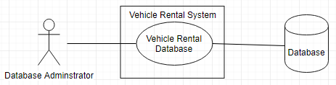

* + 1. Upload Vehicle Data

|  |  |
| --- | --- |
| Use Case Name | Upload vehicle Data |
| Scope | Under Design |
| Level | Sub-function |
| Primary Actor | Administrator |
| Stakeholders and Interest | Professor and Administrator |
| Preconditions | Database is created, Application is up and running |
| Success Guarantee | Vehicle details are uploaded and saved to database |
| Main Success Scenario | 1. Admin visits the website 2. Select file with vehicle details to upload data in database |
| Extensions | Scenario 1:  1a) Refresh the website  Scenario 2:  2a) File format Not supported, system displays message of accepted file format  Scenario 3:  2a) File unreadable/Corrupt, system ask Customer to re-upload a valid file. |
| Special Requirements | Response time should be within seconds |
| Technology and Data Variations List | Browser, Database |
| Frequency of Occurrence | Highly Used |
| Miscellaneous | NA |

Use Case Diagram: Upload vehicle Data

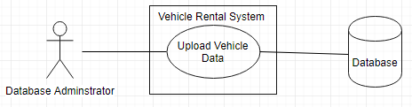

* + 1. Search a Vehicle

|  |  |
| --- | --- |
| Use Case Name | Search a Vehicle |
| Scope | Under Design |
| Level | Sub-function |
| Primary Actor | Customer |
| Stakeholders and Interest | Professor and Customer |
| Preconditions | Application should be up and running |
| Success Guarantee | List of vehicle should be available to select |
| Main Success Scenario | 1. Customer visits the website 2. Customer Enters “Pick-up Date”, “Drop Off Date” and Location 3. Customers searches the vehicle |
| Extensions | Scenario 1:  1a) Customer refresh Page  Scenario 2:  2a) Customer can enter frequently travelled destination such as Disneyland.  Scenario 3:  2a) Location entered using voice recognition  Scenario 4:  2a) Location entered using Customer’s location. |
| Special Requirements | Response time should be within seconds |
| Technology and Data Variations List | Browser, Database |
| Frequency of Occurrence | 4 hits per second |
| Miscellaneous | NA |

Use Case Diagram: Search a Vehicle

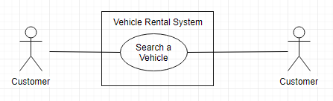

* + 1. View Vehicle Details

|  |  |
| --- | --- |
| Use Case Name | View Vehicle Details |
| Scope | Under Design |
| Level | Sub-function |
| Primary Actor | Customer |
| Stakeholders and Interest | Professor and Customer |
| Preconditions | Customer Entered Search Criteria |
| Success Guarantee | List of vehicle displayed should have details of Make and Model, Image, Price and Mileage |
| Main Success Scenario | 1. Customers searches a vehicle 2. Details of vehicles Make and Model, Image, Price and Mileage is displayed |
| Extensions | Scenario 1:  2a) Customer refresh Page |
| Special Requirements | Response time should be within seconds |
| Technology and Data Variations List | Browser, Database |
| Frequency of Occurrence | 4 hits per second |
| Miscellaneous | NA |

Use Case Diagram: View Vehicle Details

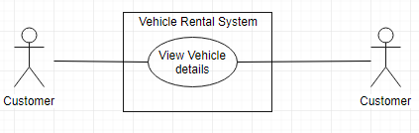

* + 1. Search on Passenger Capacity

|  |  |
| --- | --- |
| Use Case Name | Search on Passenger Capacity |
| Scope | Under Design |
| Level | Sub-function |
| Primary Actor | Customer |
| Stakeholders and Interest | Professor and Customer |
| Preconditions | Application should be up and running |
| Success Guarantee | List of vehicle displayed with defined passenger capacity |
| Main Success Scenario | 1. Customer visits the website 2. Customer Enters “Pick-up Date”, “Drop Date”, Location 3. Customer Enter Passenger Capacity 4. Customers searches the vehicle |
| Extensions | Scenario 1:  2a) Refer Use Case 3  Scenario 2:  3a) Customer re-enter Passenger Capacity |
| Special Requirements | Response time should be within seconds |
| Technology and Data Variations List | Browser, Database |
| Frequency of Occurrence | 4 hits per second |
| Miscellaneous | NA |

Use Case Diagram: Search on Passenger Capacity

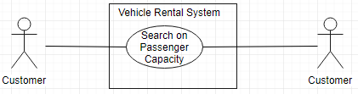

* + 1. Search on Price Range

|  |  |
| --- | --- |
| Use Case Name | Search on Price Range |
| Scope | Under Design |
| Level | Sub-function |
| Primary Actor | Customer |
| Stakeholders and Interest | Professor and Customer |
| Preconditions | Application should be up and running |
| Success Guarantee | List of vehicle displayed within the price range |
| Main Success Scenario | 1. Customer visits the website 2. Customer Enters “Pick-up Date”, “Drop Date”, Location 3. Customer Enters Price Range 4. Customers searches the vehicle |
| Extensions | Scenario 1:  2a) Refer Use Case 3  Scenario 2:  3a) Customer re-enter Price Range |
| Special Requirements | Response time should be within seconds |
| Technology and Data Variations List | Browser, Database |
| Frequency of Occurrence | 4 hits per second |
| Miscellaneous | NA |

Use Case diagram: Search on Price Range

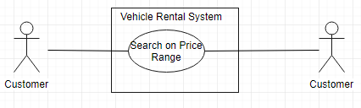

* + 1. Search on Vehicle Type

|  |  |
| --- | --- |
| Use Case Name | Search on Vehicle Type |
| Scope | Under Design |
| Level | Sub-function |
| Primary Actor | Customer |
| Stakeholders and Interest | Professor and Customer |
| Preconditions | Application should be up and running |
| Success Guarantee | List of vehicle displayed for given vehicle type |
| Main Success Scenario | 1. Customer visits the website 2. Customer Enters “Pick-up Date”, “Drop Date”, Location 3. Customer Enters Vehicle Type 4. Customers searches the vehicle |
| Extensions | Scenario 1:  2a) Refer Use Case 3  Scenario 2:  3a) Customer re-enter Vehicle Type |
| Special Requirements | Response time should be within seconds |
| Technology and Data Variations List | Browser, Database |
| Frequency of Occurrence | 4 hits per second |
| Miscellaneous | NA |

Use Case Diagram: Vehicle Type

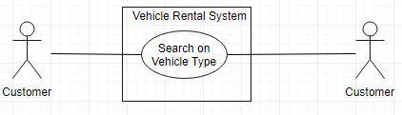

* + 1. Search on Transmission Mode

|  |  |
| --- | --- |
| Use Case Name | Search on Transmission Mode |
| Scope | Under Design |
| Level | Sub-function |
| Primary Actor | Customer |
| Stakeholders and Interest | Professor and Customer |
| Preconditions | Application should be up and running |
| Success Guarantee | List of vehicle displayed for given transmission mode |
| Main Success Scenario | 1. Customer visits the website 2. Customer Enters “Pick-up Date”, “Drop Date”, Location 3. Customer Enters Transmission Mode 4. Customers searches the vehicle |
| Extensions | Scenario 1:  2a) Refer Use Case 3  Scenario 2:  3a) Customer re-enter Transmission Mode |
| Special Requirements | Response time should be within seconds |
| Technology and Data Variations List | Browser, Database |
| Frequency of Occurrence | 4 hits per second |
| Miscellaneous | NA |

Use Case Diagram: Search on Transmission Mode

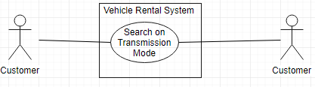

* + 1. Register an Account

|  |  |
| --- | --- |
| Use Case Name | Register an Account |
| Scope | Under Design |
| Level | Sub-function |
| Primary Actor | Customer |
| Stakeholders and Interest | Professor and Customer |
| Preconditions | Application should be up and running |
| Success Guarantee | Registered an Account |
| Main Success Scenario | 1. Customer enters username, password, First Name, Last Name, Email and DOB (Mandatory) 2. System stores Customer information and creates an account |
| Extensions | Scenario 1:  1a)Username already exists and system displays available username  1b) Customer enters new or choose from available username  Scenario 2:  1a) All fields not entered, system displays message to enter all fields  1b) Customer enters all fields value  Scenario 3:  1a) Incorrect format entered for given fields e.g. email in wrong format, system displays message to enter in correct format  1b) Customer enters correct details  Scenario 4:  2a) System unable to store details, message is displayed to re-enter details  2b) Customer re-enters details |
| Special Requirements | Response time should be within seconds |
| Technology and Data Variations List | Browser, Database |
| Frequency of Occurrence | Could be nearly continuous |
| Miscellaneous | NA |

Use Case Diagram: Register an Account

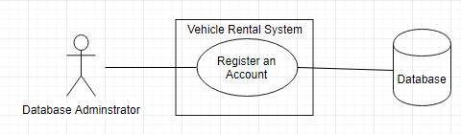

* + 1. Login to Account

|  |  |
| --- | --- |
| Use Case Name | Login to Account |
| Scope | Under Design |
| Level | Sub-function |
| Primary Actor | Customer |
| Stakeholders and Interest | Professor and Customer |
| Preconditions | Customer should be registered |
| Success Guarantee | Logged in to application |
| Main Success Scenario | 1. Customer enters valid username and password 2. Customer logged in to account |
| Extensions | Scenario 1:  1a)Username or password invalid, systems displays message and displays screen to re-enter details  1b) Customer enters valid username and password  Scenario 2:  1a) Username, password not entered, system displays message to enter username and password  1b) Customer enters username and password |
| Special Requirements | Response time should be within seconds |
| Technology and Data Variations List | Browser, Database |
| Frequency of Occurrence | Could be nearly continuous |
| Miscellaneous | NA |

Use Case Diagram: Login to account

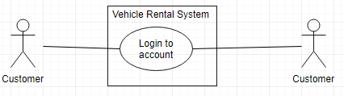

* + 1. View the bookings

|  |  |
| --- | --- |
| Use Case Name | View the bookings |
| Scope | Under Design |
| Level | Sub-function |
| Primary Actor | Customer |
| Stakeholders and Interest | Professor and Customer |
| Preconditions | Customer logged in to the account |
| Success Guarantee | View all the bookings made |
| Main Success Scenario | 1. Customer selects view Bookings 2. All bookings made by the customer is displayed. |
| Extensions | Scenario 1:  2a) Customer refresh the page if bookings not displayed |
| Special Requirements | Response time should be within seconds |
| Technology and Data Variations List | Browser, Database |
| Frequency of Occurrence | Could be nearly continuous |
| Miscellaneous | NA |

Use Case Diagram: View the bookings

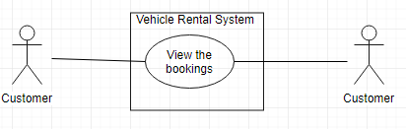

* + 1. Filter on Average Customer Rating

|  |  |
| --- | --- |
| Use Case Name | Filter on Average Customer Rating |
| Scope | Under Design |
| Level | Sub-function |
| Primary Actor | Customer |
| Stakeholders and Interest | Professor and Customer |
| Preconditions | Customer searched vehicle and list of all the vehicles is displayed |
| Success Guarantee | List of all the vehicles displayed is sorted based on average Customer Rating |
| Main Success Scenario | 1. Customer clicks on average customer rating filter and list is sorted with it where 5 star being first |
| Extensions | Scenario 1:  1a) Customer re-click average customer rating filter if list is not sorted. |
| Special Requirements | Response time should be within seconds |
| Technology and Data Variations List | Browser, Database |
| Frequency of Occurrence | Could be nearly continuous |
| Miscellaneous | NA |

Use Case Diagram: Filter on Average Customer Rating

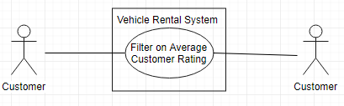

* + 1. Filter on Price Range

|  |  |
| --- | --- |
| Use Case Name | Filter on Price Range |
| Scope | Under Design |
| Level | Sub-function |
| Primary Actor | Customer |
| Stakeholders and Interest | Professor and Customer |
| Preconditions | Customer searched vehicle and list of all the vehicles is displayed |
| Success Guarantee | List of all the vehicles displayed is sorted based on Price |
| Main Success Scenario | 1. Customer clicks on Price Range filter and list is sorted with Price |
| Extensions | Scenario 1:  1a) Customer re-click Price filter if list is not sorted. |
| Special Requirements | Response time should be within seconds |
| Technology and Data Variations List | Browser, Database |
| Frequency of Occurrence | Could be nearly continuous |
| Miscellaneous | NA |

Use Case Diagram: Filter on Price Range

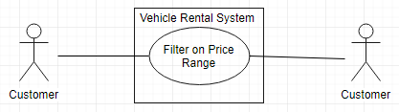

* + 1. Vehicle Pick-up Locations

|  |  |
| --- | --- |
| Use Case Name | Vehicle Pick up location |
| Scope | Under Design |
| Level | Sub-function |
| Primary Actor | Customer |
| Stakeholders and Interest | Professor and Customer |
| Preconditions | Customer selected a Vehicle |
| Success Guarantee | All the pickup locations of the vehicle are displayed |
| Main Success Scenario | 1. System displays all the pick-up points at that location |
| Extensions | Scenario 1:  1a) Refresh the page if Pick-up location not displayed. |
| Special Requirements | Response time should be within seconds |
| Technology and Data Variations List | Browser, Database |
| Frequency of Occurrence | Could be nearly continuous |
| Miscellaneous | NA |

Use Case Diagram: Vehicle Pick-up Location

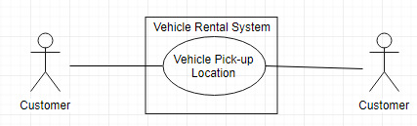

* + 1. Drop Vehicle at Home

|  |  |
| --- | --- |
| Use Case Name | Drop Vehicle at Home |
| Scope | Under Design |
| Level | Sub-function |
| Primary Actor | Customer |
| Stakeholders and Interest | Professor and Customer |
| Preconditions | Customer completes booking the rented vehicle |
| Success Guarantee | Customer entered drop off and Pick-up location to send the vehicle to after booking |
| Main Success Scenario | 1. Customer select Drop Vehicle at Home Option 2. Customer enters the location to drop off and pick-up the booked vehicle so that company will send it to that location. |
| Extensions | Scenario 1:  2a) Location not entered then ask Customer to select from a pick-up location |
| Special Requirements | Response time should be within seconds |
| Technology and Data Variations List | Browser, Database |
| Frequency of Occurrence | Could be nearly continuous |
| Miscellaneous | NA |

Use Case Diagram: Drop Vehicle at Home

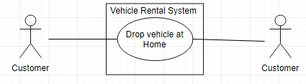

* + 1. Billing for Vehicle Booking

|  |  |
| --- | --- |
| Use Case Name | Billing for Vehicle Booking |
| Scope | Under Design |
| Level | Sub-function |
| Primary Actor | Customer |
| Stakeholders and Interest | Professor and Customer |
| Preconditions | Customer selects the vehicle |
| Success Guarantee | Customer completed the payment and booked the vehicle |
| Main Success Scenario | 1. Customer select vehicle to be rented and go to billing 2. Customer select Billing method as Cash. 3. Pays the amount and book the vehicle |
| Extensions | Scenario 1:  2a) Billing method selected is Cards  2b) Complete payment authorization for card  Scenario 2:  Scenario 1:  2a) Billing method selected is Direct Deposit  2b) Enter Direct Deposit details and complete payment  Scenario 3:  2a) Billing method selected is Android/Apple Pay  2b) Complete Payment details  Scenario 4:  2a) Billing method selected is Cashier’s Check  2b) Upload Cashier’s Check and complete the billing  Scenario 5:  2a) Use the collected reward points and complete payment |
| Special Requirements | Response time should be within seconds |
| Technology and Data Variations List | Browser, Database |
| Frequency of Occurrence | Could be nearly continuous |
| Miscellaneous | NA |

Use Case Diagram: Billing for vehicle booking

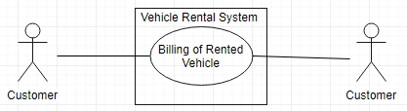

3.1.17 Receipt of booked Vehicle

|  |  |
| --- | --- |
| Use Case Name | Receipt of a booked Vehicle |
| Scope | Under Design |
| Level | Sub function |
| Primary Actor | Customer |
| Stakeholders and Interest | Professor and Customer |
| Preconditions | Vehicle should be rented |
| Success Guarantee | Receipt is generated |
| Main Success Scenario | 1. System presents receipt 2. Customer receives a receipt |
| Extensions | Scenario 1:  2a) Customer has to retry |
| Special Requirements | Response time should be within seconds |
| Technology and Data Variations List | Browser, Database |
| Frequency of Occurrence | Could be nearly continuous |
| Miscellaneous | N/A |

Use Case Diagram: Receipt of booked vehicle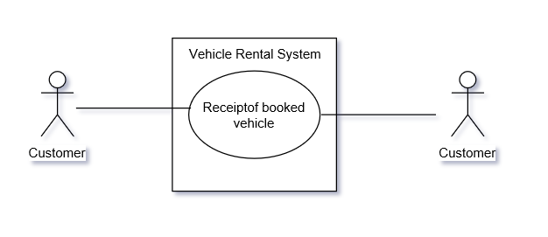

* + 1. Adding Additional Drivers with insurance

|  |  |
| --- | --- |
| Use Case Name | Adding additional drivers |
| Scope | Under Design |
| Level | Sub function |
| Primary Actor | Customer |
| Stakeholders and Interest | Professor and Customer |
| Preconditions | Should have Primary driver and vehicle should be rented |
| Success Guarantee | Adds additional driver |
| Main Success Scenario | 1. Customer booked vehicle becomes a primary driver  2. Customer adds additional driver  3. Customer includes insurance of additional driver details |
| Extensions | Scenario 1:  2a) Customer has to retry adding additional drivers details and insurance |
| Special Requirements | Response time should be within seconds |
| Technology and Data Variations List | Browser, Database |
| Frequency of Occurrence | Could be nearly continuous |
| Miscellaneous | N/A |

Use Case Diagram: Adding additional drivers with insurance

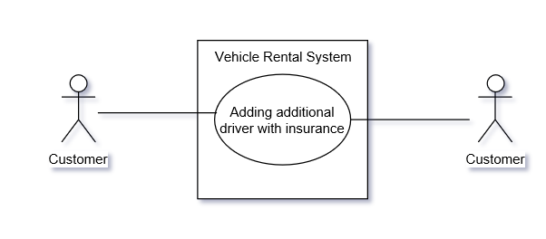

* + 1. Printing receipt of booked vehicle

|  |  |
| --- | --- |
| Use Case Name | Printing receipt |
| Scope | Under Design |
| Level | Sub function |
| Primary Actor | Customer |
| Stakeholders and Interest | Professor and Customer |
| Preconditions | Vehicle should be rented |
| Success Guarantee | Receipt is printed |
| Main Success Scenario | 1. System presents receipt 2. Customer receives a receipt 3. Customer prints a receipt |
| Extensions | Scenario 1:  2a) Customer has to retry  Scenario 2:  3a) Customer has to re-print |
| Special Requirements | Response time should be within seconds |
| Technology and Data Variations List | Browser, Database |
| Frequency of Occurrence | Could be nearly continuous |
| Miscellaneous | N/A |

Use Case Diagram: Printing receipt of booked vehicle

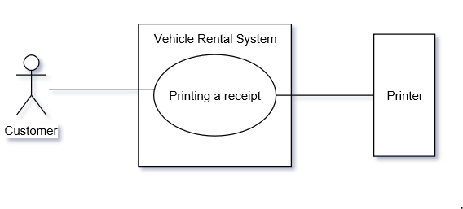

* + 1. Upgrade an existing booking

|  |  |
| --- | --- |
| Use Case Name | Upgrade an Existing booking |
| Scope | Under Design |
| Level | Sub function |
| Primary Actor | Customer |
| Stakeholders and Interest | Professor and Customer |
| Preconditions | Vehicle should be rented |
| Success Guarantee | Upgraded booking |
| Main Success Scenario | 1. Customer retrieves his booking 2. Customer selects an upgraded vehicle. 3. Customer booked an upgraded vehicle and updated in the database |
| Extensions | Scenario 1:  1a) Customer have to re-try to retrieve his booking  Scenario 2:  2a) If vehicle is not upgraded, Customer has to re-select the upgraded vehicle |
| Special Requirements | Response time should be within seconds |
| Technology and Data Variations List | Browser, Database |
| Frequency of Occurrence | Could be nearly continuous |
| Miscellaneous | N/A |

Use Case Diagram: Upgrade an existing booking

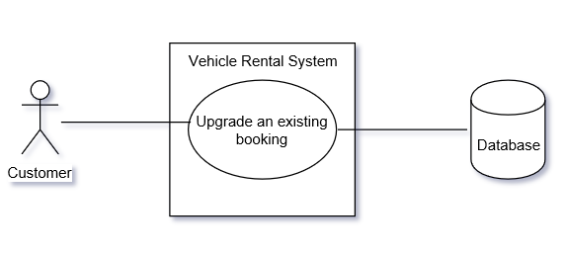

3.1.21 Assign privileges to Customer

|  |  |
| --- | --- |
| Use Case Name | Assign privileges to Customer |
| Scope | Under Design |
| Level | Sub function |
| Primary Actor | Administrator |
| Stakeholders and Interest | Professor and Administrator |
| Preconditions | Customer should be a member |
| Success Guarantee | Customer can view their bookings |
| Main Success Scenario | 1. Administrator should assign privileges to customer to view all his bookings 2. Customer views his bookings |
| Extensions | Scenario 1:  2a) Customer has to refresh the page to view his bookings |
| Special Requirements | Response time should be within seconds |
| Technology and Data Variations List | Browser, Database |
| Frequency of Occurrence | Could be nearly continuous |
| Miscellaneous | N/A |

Use Case Diagram: Assign privileges to customer

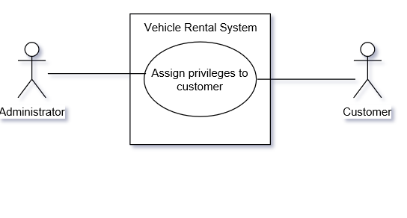

* + 1. Search vehicle with voice recognition

|  |  |
| --- | --- |
| Use Case Name | Search vehicle with voice recognition |
| Scope | Under Design |
| Level | Sub function |
| Primary Actor | Customer |
| Stakeholders and Interest | Professor and Customer |
| Preconditions | Application should be up and running |
| Success Guarantee | List of vehicles should be available to select |
| Main Success Scenario | 1. Customer visits the website 2. Customer selects voice recognition option 3. Customer speaks to search a vehicle |
| Extensions | Scenario 1:  1a) Customer refresh Page  Scenario 2:  3a)Customer has to type to search for a vehicle |
| Special Requirements | Response time should be within seconds |
| Technology and Data Variations List | Browser, Database |
| Frequency of Occurrence | Could be nearly continuous |
| Miscellaneous | N/A |

Use Case Diagram: Search vehicle with voice recognition

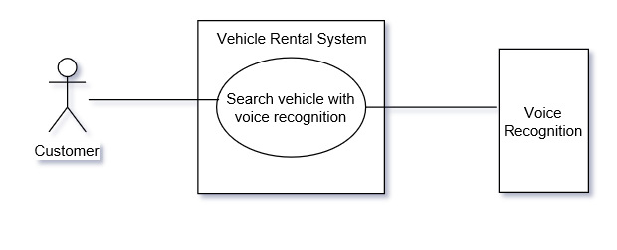

* + 1. Modify future booking

|  |  |
| --- | --- |
| Use Case Name | Modify future booking |
| Scope | Under Design |
| Level | Sub function |
| Primary Actor | Customer |
| Stakeholders and Interest | Professor and Customer |
| Preconditions | Vehicle should be rented and have confirmation number |
| Success Guarantee | Modify booking |
| Main Success Scenario | 1. Customer retrieves his booking 2. Customer modifies his booking. 3. Modified booking is saved and updated to database |
| Extensions | Scenario 1:  1a) Customer re-tries to retrieve his booking  Scenario 2:  2a) Customer re-enters the modified booking details |
| Special Requirements | Response time should be within seconds |
| Technology and Data Variations List | Browser, Database |
| Frequency of Occurrence | Could be nearly continuous |
| Miscellaneous | N/A |

Use Case Diagram: Modify future booking

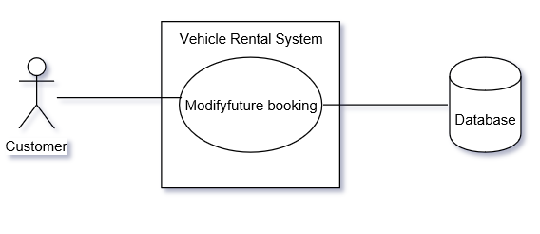

* + 1. Cancel future booking

|  |  |
| --- | --- |
| Use Case Name | Cancel future booking |
| Scope | Under Design |
| Level | Sub function |
| Primary Actor | Customer |
| Stakeholders and Interest | Professor and Customer |
| Preconditions | Vehicle should be rented and have confirmation number |
| Success Guarantee | Cancel booking |
| Main Success Scenario | 1. Customer retrieves his booking. 2. Customer can cancel his booking. 3. Cancelled booking is saved and updated to database |
| Extensions | Scenario 1:  1a) Customer re-tries to retrieve his booking  Scenario 2:  2a) customer should try to re- cancel the booking |
| Special Requirements | Response time should be within seconds |
| Technology and Data Variations List | Browser, Database |
| Frequency of Occurrence | Could be nearly continuous |
| Miscellaneous | N/A |

Use Case Diagram: Cancel future booking

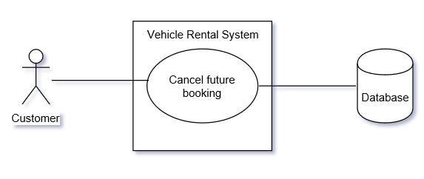

* + 1. Provide Insurance details

|  |  |
| --- | --- |
| Use Case Name | Provide Insurance details |
| Scope | Under Design |
| Level | Sub function |
| Primary Actor | Customer |
| Stakeholders and Interest | Professor and Customer |
| Preconditions | Customer should have a booking |
| Success Guarantee | Insurance can be waived to rent a vehicle |
| Main Success Scenario | 1. Customer provides insurance details 2. Insurance is waived off |
| Extensions | Scenario 1:  1a) Company provides insurance |
| Special Requirements | Response time should be within seconds |
| Technology and Data Variations List | Browser, Database |
| Frequency of Occurrence | Could be nearly continuous |
| Miscellaneous | N/A |

Use Case Diagram: Providing Insurance details

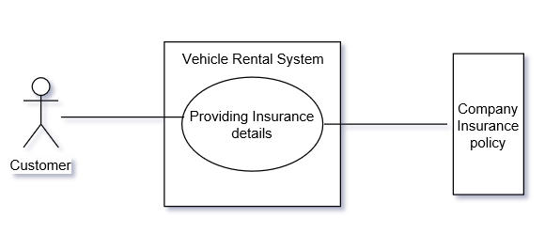

* + 1. View Terms and Conditions

|  |  |
| --- | --- |
| Use Case Name | View Terms and conditions |
| Scope | Under Design |
| Level | Sub function |
| Primary Actor | Customer |
| Stakeholders and Interest | Professor and Customer |
| Preconditions | Application should be up and running |
| Success Guarantee | Customer views terms and conditions |
| Main Success Scenario | 1.Customer enter details to register  2.Customer views terms and conditions |
| Extensions | Scenario 1:  2a) Customer should reload the page and re-enter the details |
| Special Requirements | Response time should be within seconds |
| Technology and Data Variations List | Browser, Database |
| Frequency of Occurrence | Could be nearly continuous |
| Miscellaneous | N/A |

Use Case Diagram: View Terms and Conditions

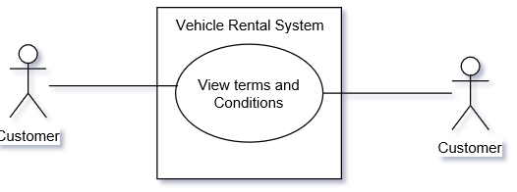

* + 1. Choose a language

|  |  |
| --- | --- |
| Use Case Name | Choose a language |
| Scope | Under Design |
| Level | Sub function |
| Primary Actor | Customer |
| Stakeholders and Interest | Professor and Customer |
| Preconditions | Application should be up and running |
| Success Guarantee | Customer able to view the web in specified language |
| Main Success Scenario | 1. Customer chooses a language |
| Extensions | Scenario 1:  1a) Customer re-chooses the language |
| Special Requirements | Response time should be within seconds |
| Technology and Data Variations List | Browser, Database |
| Frequency of Occurrence | Could be nearly continuous |
| Miscellaneous | N/A |

Use Case Diagram: Choose a language

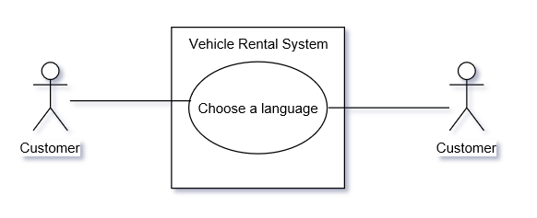

* + 1. Rent a vehicle for long term

|  |  |
| --- | --- |
| Use Case Name | Rent a vehicle for long term |
| Scope | Under Design |
| Level | Sub function |
| Primary Actor | Customer |
| Stakeholders and Interest | Professor and Customer |
| Preconditions | Application should be up and running |
| Success Guarantee | Long term rentals |
| Main Success Scenario | 1. Customer visits the website 2. Customer chooses a vehicle 3. Customer rents for long term |
| Extensions | Scenario 1:  1a) Customer refreshes website |
| Special Requirements | Response time should be within seconds |
| Technology and Data Variations List | Browser, Database |
| Frequency of Occurrence | Could be nearly continuous |
| Miscellaneous | N/A |

Use Case Diagram: Rent a vehicle for long term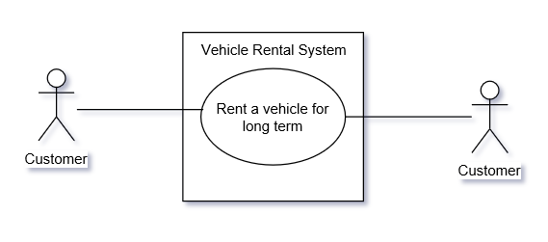

* + 1. View reward points

|  |  |
| --- | --- |
| Use Case Name | View reward points |
| Scope | Under Design |
| Level | Sub function |
| Primary Actor | Customer |
| Stakeholders and Interest | Professor and Customer |
| Preconditions | Customer should be logged into the system |
| Success Guarantee | View reward points |
| Main Success Scenario | 1. Customer selects to view reward points |
| Extensions | Scenario 1:  1a) Customer reloads to review the reward points |
| Special Requirements | Response time should be within seconds |
| Technology and Data Variations List | Browser, Database |
| Frequency of Occurrence | Could be nearly continuous |
| Miscellaneous | N/A |

Use Case Diagram: View reward points

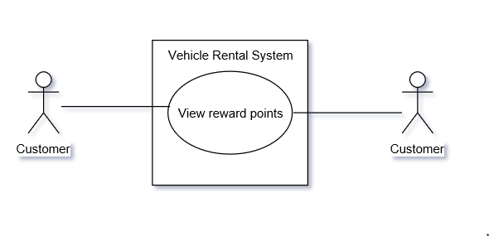

* + 1. Rate and Review

|  |  |
| --- | --- |
| Use Case Name | Rate and Review |
| Scope | Under Design |
| Primary Actor | Customer |
| Stakeholders and Interest | Professor and Customer |
| Preconditions | Customer should complete his/her Trip |
| Success Guarantee | Ratings and Reviews are updated. |
| Main Success Scenario | 1. Customer visits the website 2. Customer enter the rating and reviews the experience 3. Ratings and Reviews are updated |
| Extensions | Scenario 1:  1a) Customer refreshes Page  Scenario 2:  2a) Customer is asked to re-enter the rating and review |
| Special Requirements | Response time should be within seconds |
| Technology and Data Variations List | Browser, Database |
| Frequency of Occurrence | Could be nearly continuous |
| Miscellaneous | NA |

Use Case Diagram: Rate and Review

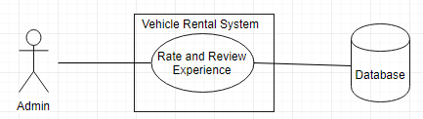

* + 1. Choose Additional Accessories

|  |  |
| --- | --- |
| Use Case Name | Choose additional accessories |
| Scope | Under Design |
| Level | Sub Function |
| Primary Actor | Customer |
| Stakeholders and Interest | Professor, Customer |
| Preconditions | Customer needs to select a vehicle |
| Success Guarantee | List of Accessories are displayed and selected |
| Main Success Scenario | 1.Customer searches for additional accessories  2.Customer selects additional accessories |
| Extensions | Scenario 1:  1a) Customer refreshes Page |
| Special Requirements | Response time should be within seconds |
| Technology and Data Variations List | Browser, Database |
| Frequency of Occurrence | Could be nearly continuous |
| Miscellaneous | NA |

Use Case Diagram: Choose additional accessories

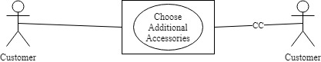

* + 1. Pick up and Drop off Location

|  |  |
| --- | --- |
| Use Case Name | Select Pick up and Drop off location |
| Scope | Under Design |
| Level | Sub Function |
| Primary Actor | Customer |
| Stakeholders and Interest | Professor, Customer |
| Preconditions | Customer should have selected vehicle |
| Success Guarantee | Selects Customers Pick up and Drop off location |
| Main Success Scenario | 1.Customer visits the website  2.Customer select pick up and Drop off location |
| Extensions | Scenario 1:  1a) Customer Re-select pick up and drop off location |
| Special Requirements | Response time should be within seconds |
| Technology and Data Variations List | Browser, Database |
| Frequency of Occurrence | could be nearly continuous |
| Miscellaneous | NA |

Use Case Diagram: Pick up and Drop off location

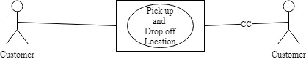

* + 1. Access to Reports

|  |  |
| --- | --- |
| Use Case Name | Access to Reports |
| Scope | Under Design |
| Level | Sub Function |
| Primary Actor | Administrator |
| Stakeholders and Interest | Professor, Administrator |
| Preconditions | Application should be up and running |
| Success Guarantee | Reports are displayed |
| Main Success Scenario | 1.Administrator visits the website  2.Administrator selects the type of report  3.The Reports are displayed |
| Extensions | Scenario 1:  1a) Administrator refreshes Page  2a) Administrator Re-selects the type of reports |
| Special Requirements | Response time should be within seconds |
| Technology and Data Variations List | Browser, Database |
| Frequency of Occurrence | could be nearly continuous |
| Miscellaneous | NA |

Use Case Diagram: Access to Reports

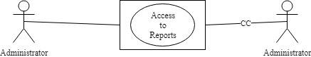

* + 1. View Special Rates

|  |  |
| --- | --- |
| Use Case Name | View Special rates |
| Scope | Under Design |
| Level | Sub Function |
| Primary Actor | Customers |
| Stakeholders and Interest | Professor, Customer |
| Preconditions | Application should be up and running |
| Success Guarantee | All the special rates are displayed |
| Main Success Scenario | 1.Customer visits the website  2.Customer views special rates |
| Extensions | Scenario 1:  1a) Customer refreshes Page |
| Special Requirements | Response time should be within seconds |
| Technology and Data Variations List | Browser, Database |
| Frequency of Occurrence | 4 hits per second |
| Miscellaneous | NA |

Use Case Diagram: View special rates

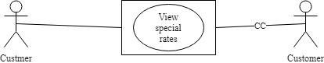

* + 1. Manage Memberships

|  |  |
| --- | --- |
| Use Case Name | Manage Memberships |
| Scope | Under Design |
| Level | Sub Function |
| Primary Actor | Administrator, Customer |
| Stakeholders and Interest | Professor, Customer |
| Preconditions | Application should be up and running |
| Success Guarantee | Administrator assigns Customers with Memberships |
| Main Success Scenario | 1.Admin visits the website  2.Admin selects Customer to assign membership  3. Customers are assigned Membership |
| Extensions | Scenario 1:  1a) Administrator refreshes Page  2a) Administrator reassigns memberships |
| Special Requirements | Response time should be within seconds |
| Technology and Data Variations List | Browser, Database |
| Frequency of Occurrence | could be nearly continuous |
| Miscellaneous | NA |

Use Case Diagram: Manage Memberships



* + 1. Access to Driving Records

|  |  |
| --- | --- |
| Use Case Name | Access to Driving Records |
| Scope | Under Design |
| Level | Sub Function |
| Primary Actor | Administrator |
| Stakeholders and Interest | Professor, Customer |
| Preconditions | Customer should have booked a vehicle |
| Success Guarantee | Driver’s Previous Records are displayed |
| Main Success Scenario | 1.Administrator visits the website  2.Administrator access the Driver’s Records  3.Adminitrattor allows customer to book the vehicle |
| Extensions | Scenario 1:  1a) If there are any red flags in the in driver’s records, the booking is cancelled |
| Special Requirements | Response time should be within seconds |
| Technology and Data Variations List | Browser, Database |
| Frequency of Occurrence | could be nearly continuous |
| Miscellaneous | NA |

Use Case Diagram: Access Driver’s previous Records

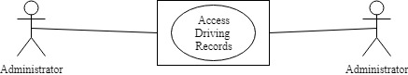

* + 1. Redeem Reward Points

|  |  |
| --- | --- |
| Use Case Name | Redeem Rewards Points |
| Scope | Under Design |
| Level | Sub Function |
| Primary Actor | Customers |
| Stakeholders and Interest | Professor, Customer |
| Preconditions | Customer must be logged into the system |
| Success Guarantee | Customers Reward Points are Redeemed |
| Main Success Scenario | 1.Customer selects redeem reward points  2.Customer Redeems Reward Points for merchandize  3.The Rewards points are deducted from account |
| Extensions | Scenario 1:  1a) Customer refreshes Page  3a) If Redeeming points is unsuccessful, points are returned to the account |
| Special Requirements | Response time should be within seconds |
| Technology and Data Variations List | Browser, Database |
| Frequency of Occurrence | could be nearly continuous |
| Miscellaneous | NA |

Use Case Diagram: Redeem reward Points

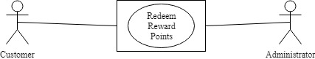

* + 1. Navigate Pick Up Location

|  |  |
| --- | --- |
| Use Case Name | Navigate Pick Up Location |
| Scope | Under Design |
| Level | Sub Function |
| Primary Actor | Customers |
| Stakeholders and Interest | Professor, Customer |
| Preconditions | Customer has completed the car booking |
| Success Guarantee | Customer has navigated his location using map |
| Main Success Scenario | 1.Customer Navigates Pick Up Location using maps |
| Extensions | Scenario 1:  1a) Customer reloads the maps |
| Special Requirements | Response time should be within seconds |
| Technology and Data Variations List | Browser, Database |
| Frequency of Occurrence | could be nearly continuous |
| Miscellaneous | NA |

Use Case Diagram: Navigate Pick Up location

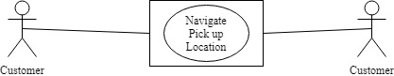

* + 1. Access to customer benefits

|  |  |
| --- | --- |
| Use Case Name | Access to customer benefits |
| Scope | Under Design |
| Level | Sub Function |
| Primary Actor | Customers |
| Stakeholders and Interest | Professor, Customer |
| Preconditions | Customer should be registered and logged in |
| Success Guarantee | Customer gets access to customer benefits |
| Main Success Scenario | 1.Customer visits the website  2.Customer selects multiple customer benefits |
| Extensions | Scenario 1:  1a) Customer refreshes Page |
| Special Requirements | Response time should be within seconds |
| Technology and Data Variations List | Browser, Database |
| Frequency of Occurrence | could be nearly continuous |
| Miscellaneous | NA |

Use Case Diagram: Access to customer benefits

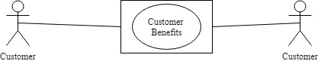

* + 1. Provide Promotions, Membership rewards points, Family benefits

|  |  |
| --- | --- |
| Use Case Name | Provide promotions, membership rewards points, family benefits |
| Scope | Under Design |
| Level | Sub Function |
| Primary Actor | Administrator, Customer |
| Stakeholders and Interest | Professor, Customer |
| Preconditions | Customer should be registered |
| Success Guarantee | Administrator provides promotions, membership rewards points, family benefits |
| Main Success Scenario | 1.Administrator visits the website  2.Aministrator checks for membership  3.Administrator Provides promotions, membership rewards points, family benefits to Customers |
| Extensions | Scenario 1:  1a) Administrator refreshes Page  2a) If customer is not a member then page redirects to registration |
| Special Requirements | Response time should be within seconds |
| Technology and Data Variations List | Browser, Database |
| Frequency of Occurrence | could be nearly continuous |
| Miscellaneous | NA |

Use Case Diagram: Provide promotions, membership rewards points, family benefits

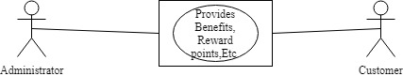

* + 1. Administrator Should Provide Proper Encryption

|  |  |
| --- | --- |
| Use Case Name | Encryption to Customers Credentials |
| Scope | Under Design |
| Level | Sub Function |
| Primary Actor | Administrator, Customer |
| Stakeholders and Interest | Professor, Customer |
| Preconditions | Application should be up and running |
| Success Guarantee | Customers credentials are encrypted |
| Main Success Scenario | 1.Administrator visits the website  2.Administrator encrypts Customer credentials |
| Extensions | Scenario 1:  1a) Administrator refreshes Page |
| Special Requirements | Response time should be within seconds |
| Technology and Data Variations List | Browser, Database |
| Frequency of Occurrence | could be nearly continuous |
| Miscellaneous | NA |

Use Case Diagram: Encrypt Customer Credentials

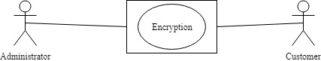

* + 1. Choose calendar day

|  |  |
| --- | --- |
| Use Case Name | Choose Calendar Day or 24-hour day |
| Scope | Under Design |
| Level | Sub Function |
| Primary Actor | Customer |
| Stakeholders and Interest | Professor, Customer |
| Preconditions | Application should be up and running |
| Success Guarantee | Customers selects a Calendar day |
| Main Success Scenario | 1.Customer visits the website  2.Customer selects a calendar day |
| Extensions | Scenario 1:  1a) Customer refreshes Page |
| Special Requirements | Response time should be within seconds |
| Technology and Data Variations List | Browser, Database |
| Frequency of Occurrence | could be nearly continuous |
| Miscellaneous | NA |

Use Case Diagram: Calendar Day or 24 hour day

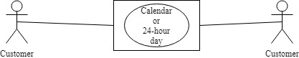

* + 1. Customize Payments

|  |  |
| --- | --- |
| Use Case Name | Customize Payments |
| Scope | Under Design |
| Level | Sub Function |
| Primary Actor | Customer |
| Stakeholders and Interest | Professor, Customer |
| Preconditions | Customer should select a Vehicle |
| Success Guarantee | Customers customizes payments |
| Main Success Scenario | 1.Customer selects onetime payment or instalments  2.Booking is confirmed |
| Extensions | Scenario 1:  2a) Customer re-selects payments |
| Special Requirements | Response time should be within seconds |
| Technology and Data Variations List | Browser, Database |
| Frequency of Occurrence | could be nearly continuous |
| Miscellaneous | NA |

Use Case Diagram: Customize payments

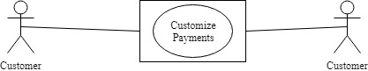

* + 1. Payment through PayPal

|  |  |
| --- | --- |
| Use Case Name | Payment through PayPal |
| Scope | Under Design |
| Level | Sub Function |
| Primary Actor | Customer |
| Stakeholders and Interest | Professor, Customer |
| Preconditions | Customer has selected a vehicle |
| Success Guarantee | Customers pays through PayPal |
| Main Success Scenario | 1.Customer selects PayPal as payment option  2.Customer pays using PayPal  3. PayPal will authorize payment |
| Extensions | Scenario 1:  1a) Customer refreshes Page  2a) Customer selects other payment method |
| Special Requirements | Response time should be within seconds |
| Technology and Data Variations List | Browser, Database |
| Frequency of Occurrence | could be nearly continuous |
| Miscellaneous | NA |

Use Case Diagram: Payment using PayPal

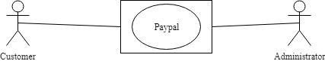

### 3.2 CLASS DIAGRAM

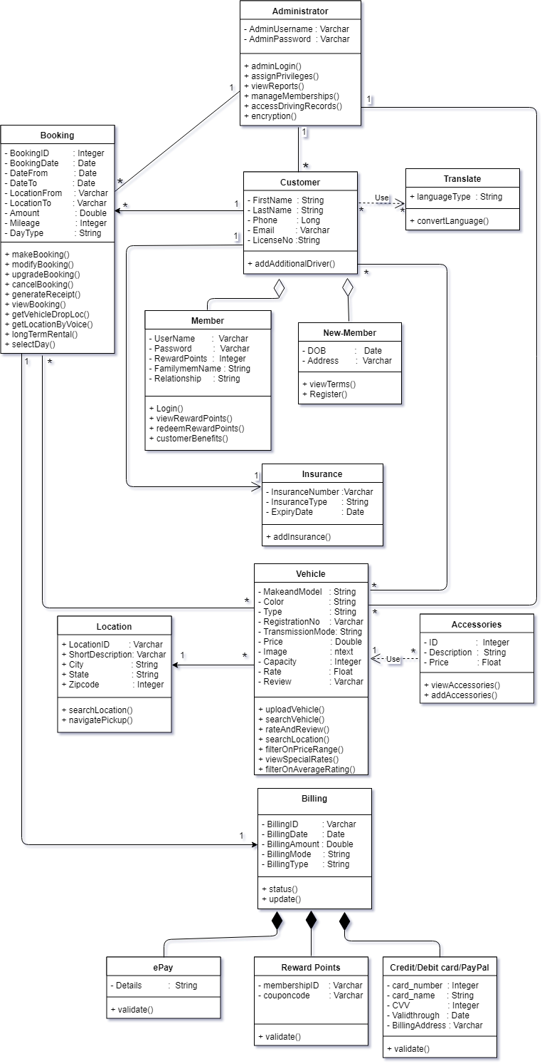

### 3.3 INTERACTION DIAGRAMS

#### 3.3.1 Sequence diagrams

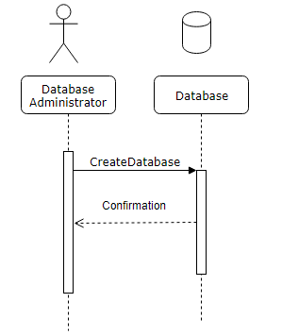

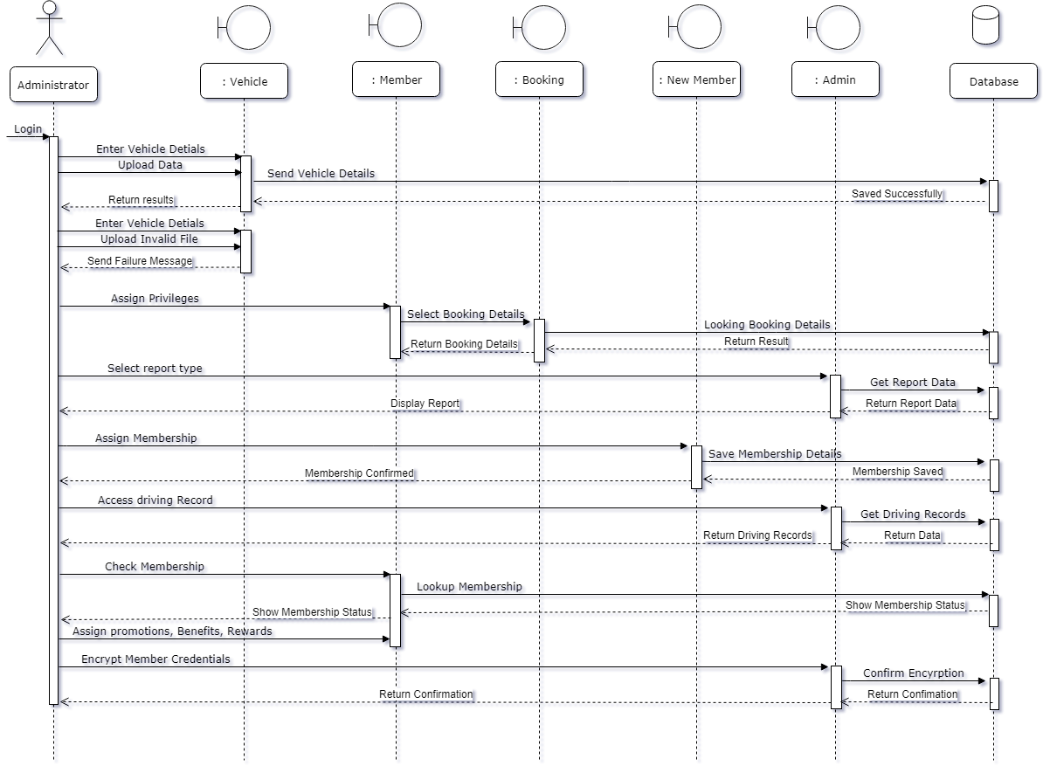

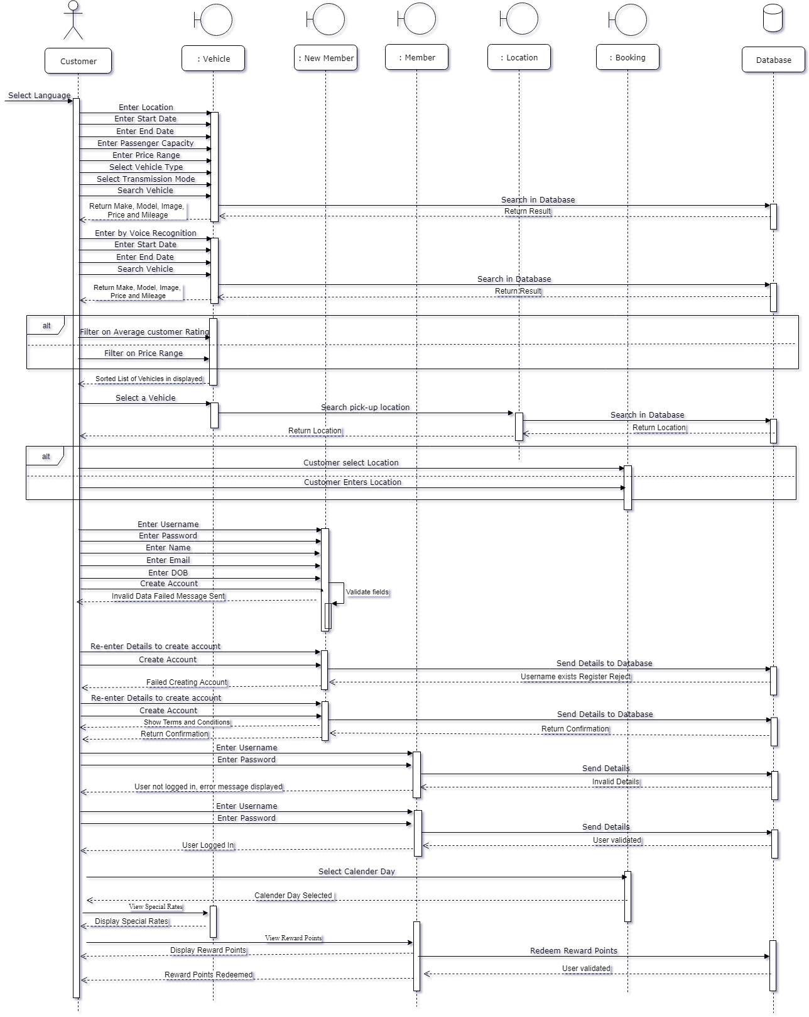

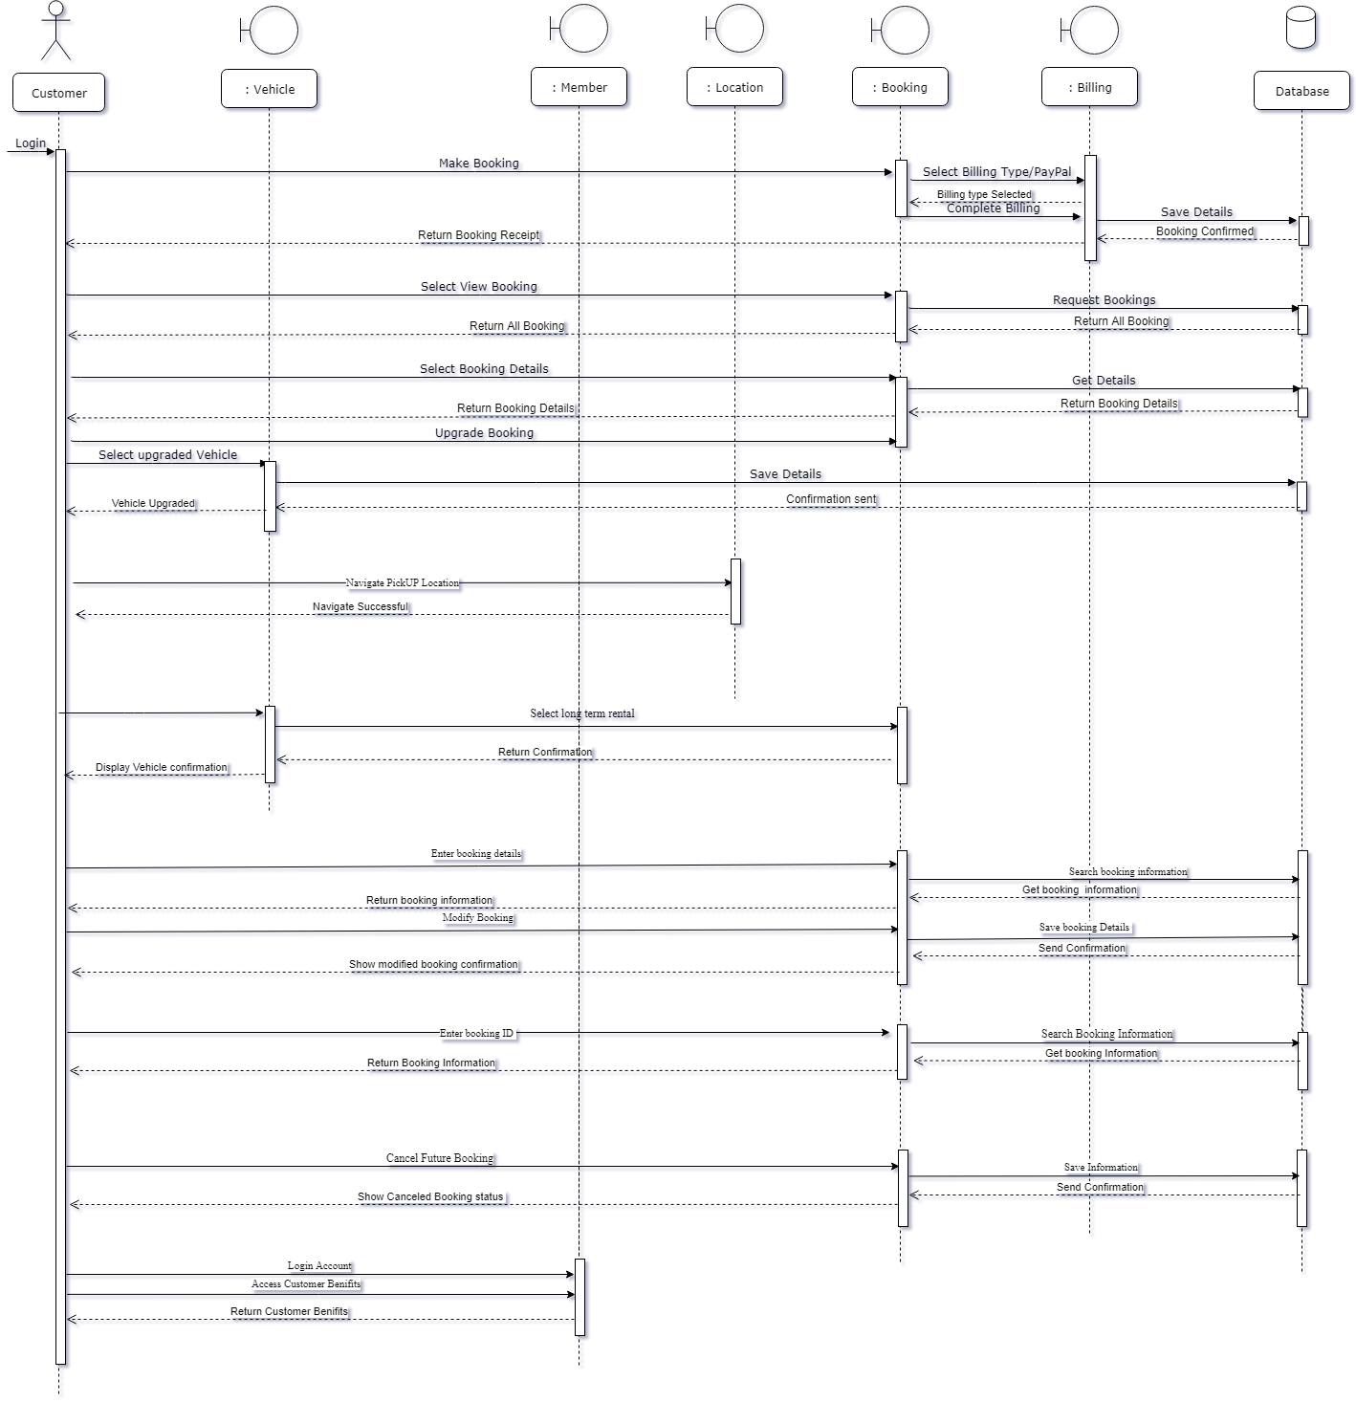

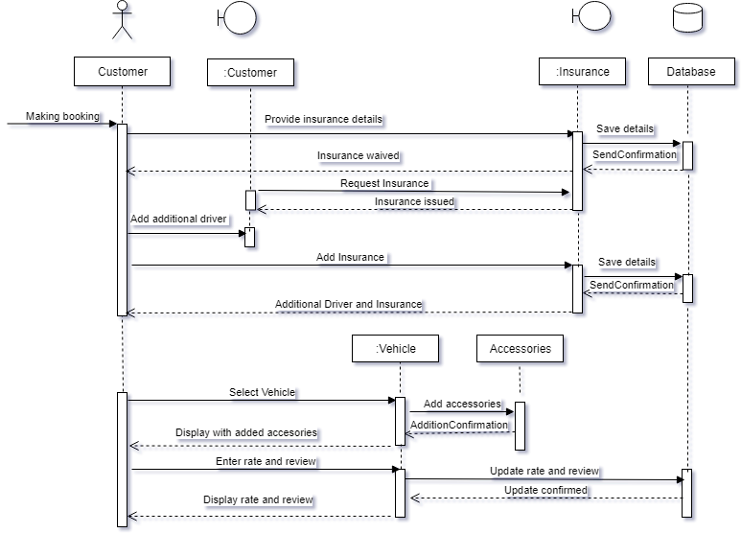

#### 3.3.2 Communication Diagrams

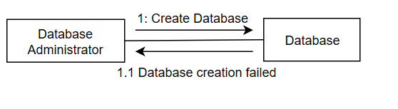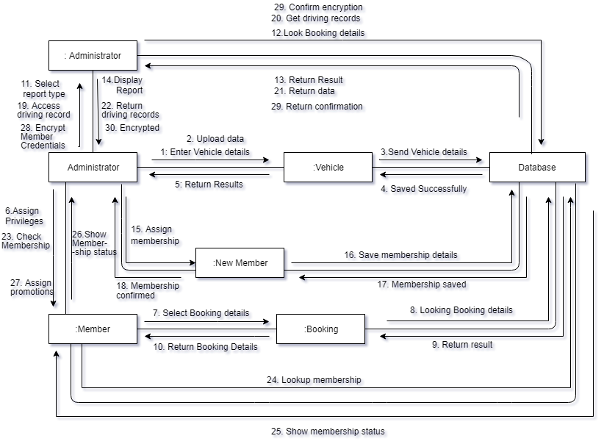

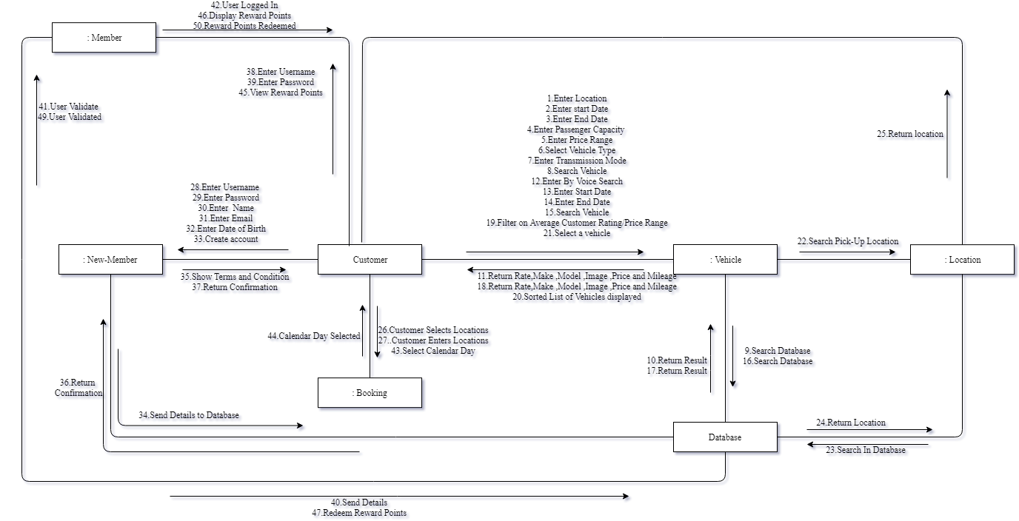

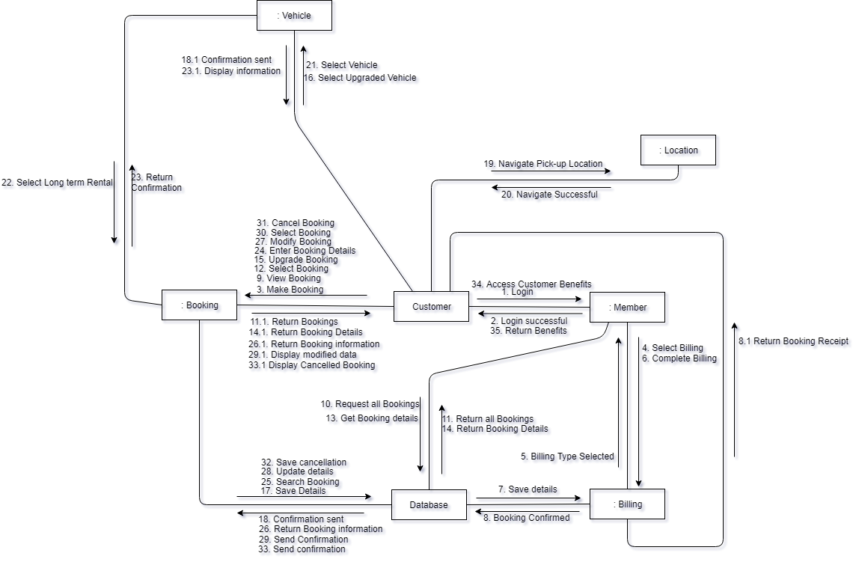

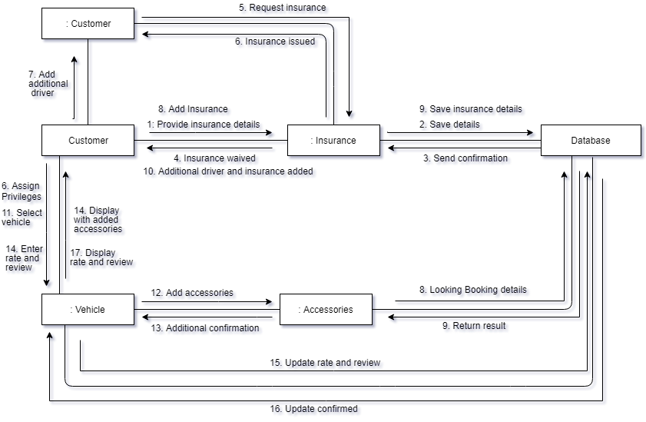

### 3.4 STATE DIAGRAM

#### 3.4.1 Admin

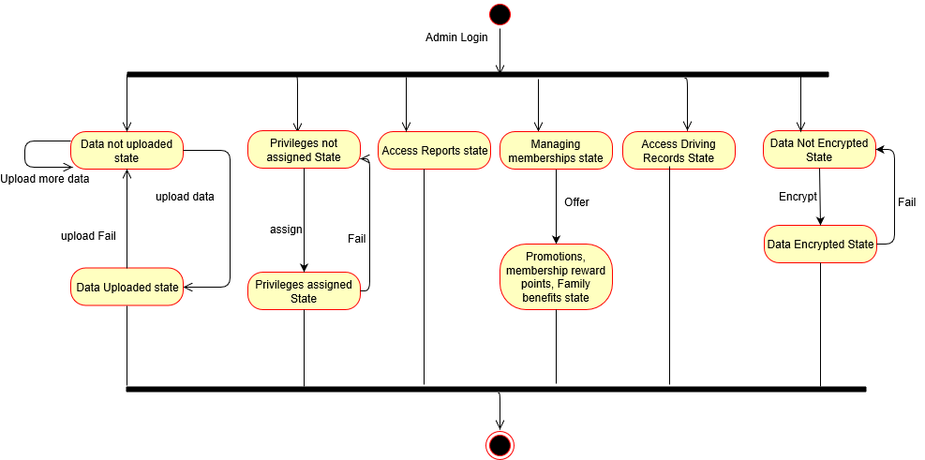

#### 3.4.2 Vehicle

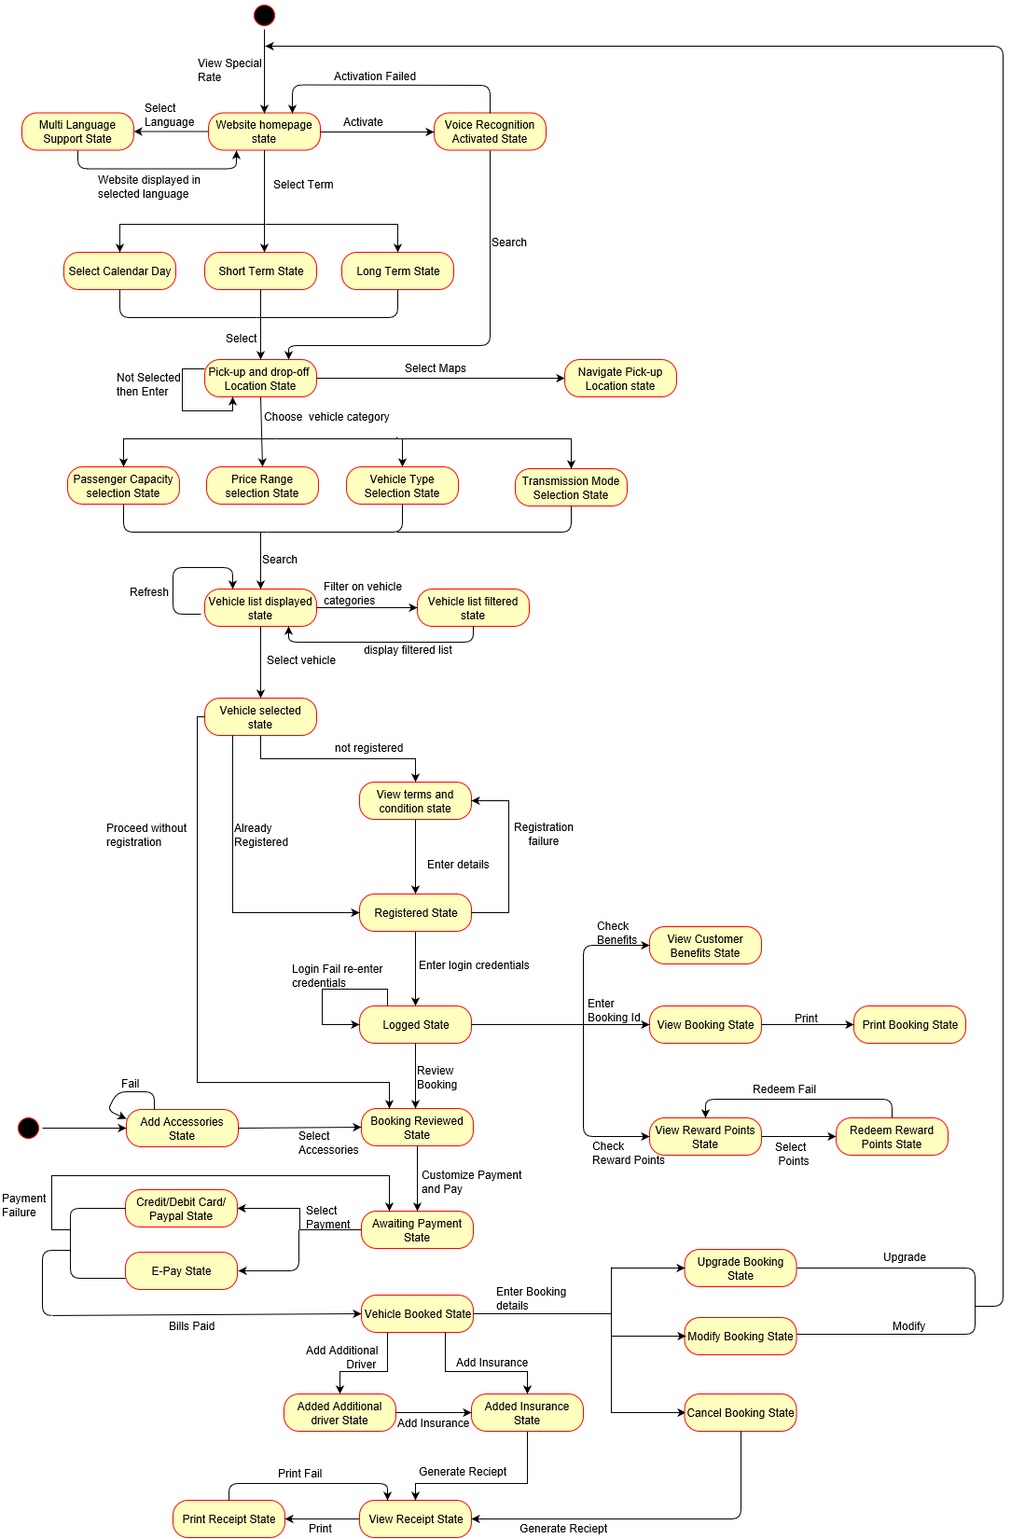

#### Rate and Review

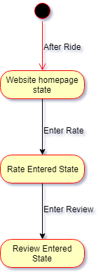

### 3.5 SERVICE ORIENTED ARCHITECTURE

#### 3.5.1 Authentication service

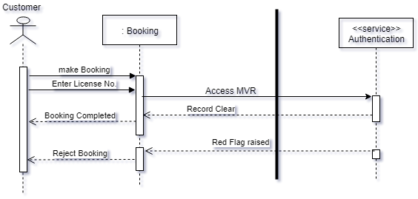

#### 3.5.2 Translate service and vehicle service

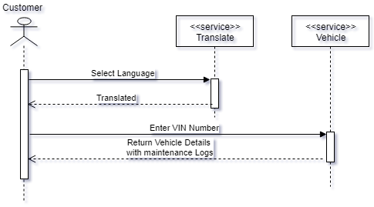

### 3.6 GRASP

#### 3.6.1 Polymorphism Pattern for Billing

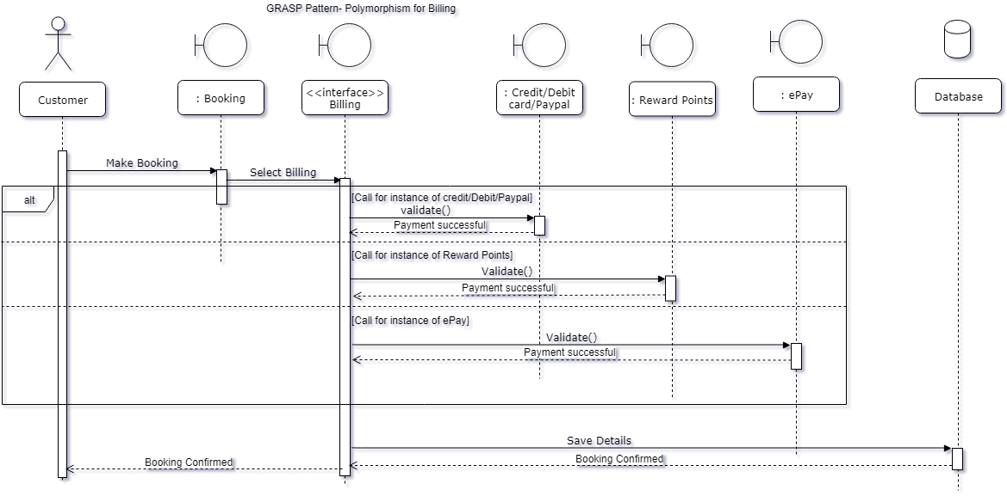

#### Creator Pattern for Vehicle and Accessories

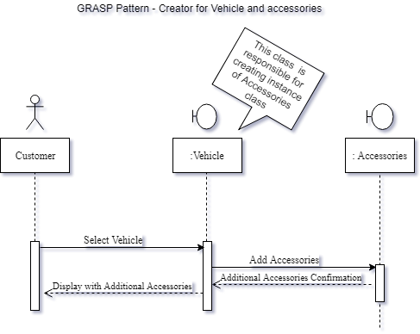

### 3.7 GoF PATTERNS- Factory pattern

3.7.1 Vehicle Type (Sequence Diagram)

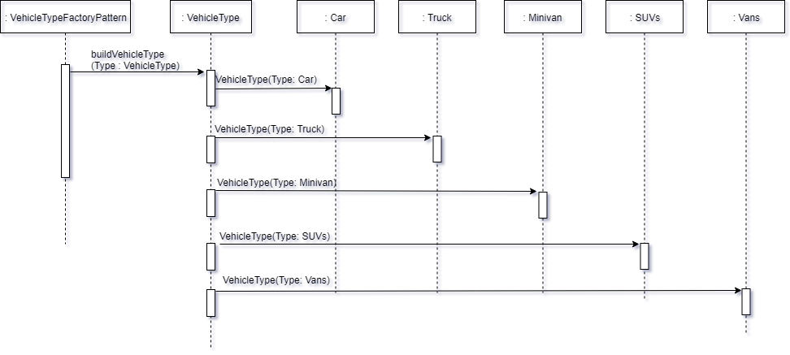

3.7.2 Vehicle Type (Class Diagram)

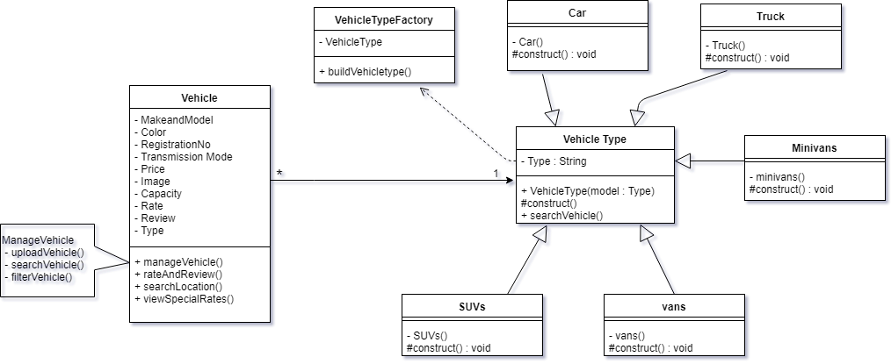

3.7.3 Transmission Mode(Class Diagram)

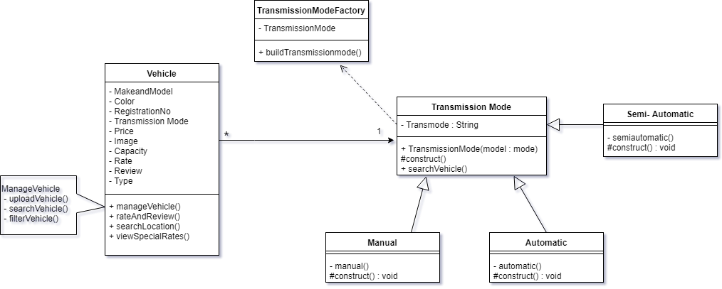

* + 1. Transmission Mode(Sequence Diagram)

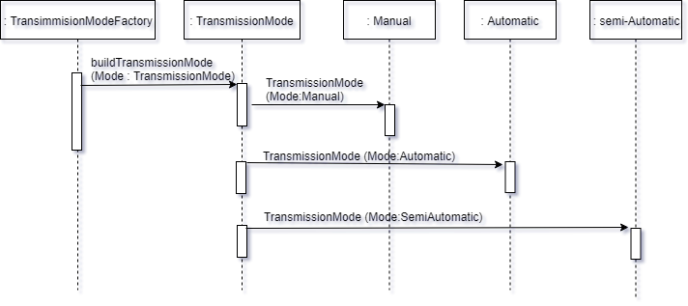

# 4. USER INTERFACE AND FUNCTIONS

* 1. User Interfaces

User Interface will follow standard viewing procedure. Look and Feel will maintain high visibility throughout the website. The background in light in color with dark colored font to enhance the contrast and visibility for the user. Links (Buttons) will make use of visible color and be relation to the respective page to which they navigate.

1. Home 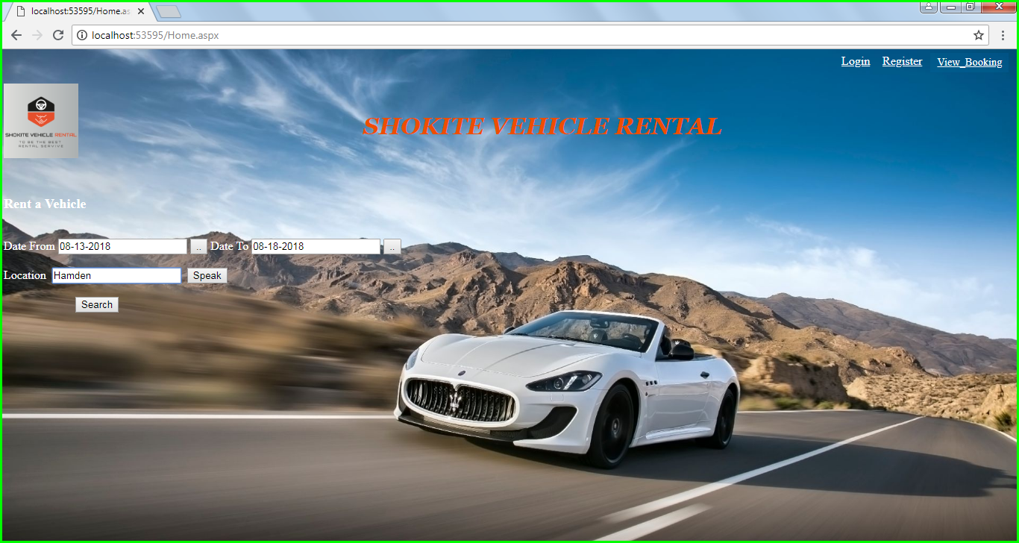

* User selects from date
* User selects to date
* User enters location or uses voice recognition to speak location
* User selects search option

1. Vehicle

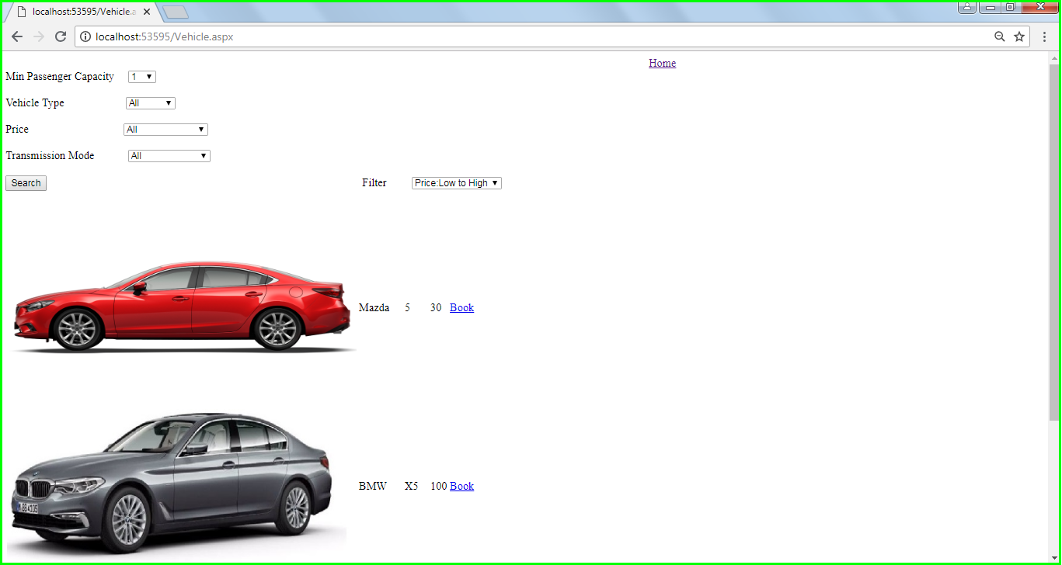

* User selects psaaenger capacity
* User selects vehicle type, price and transmission mode
* User selects search
* User then views all the vehicles avaliable and selects book

1. Booking

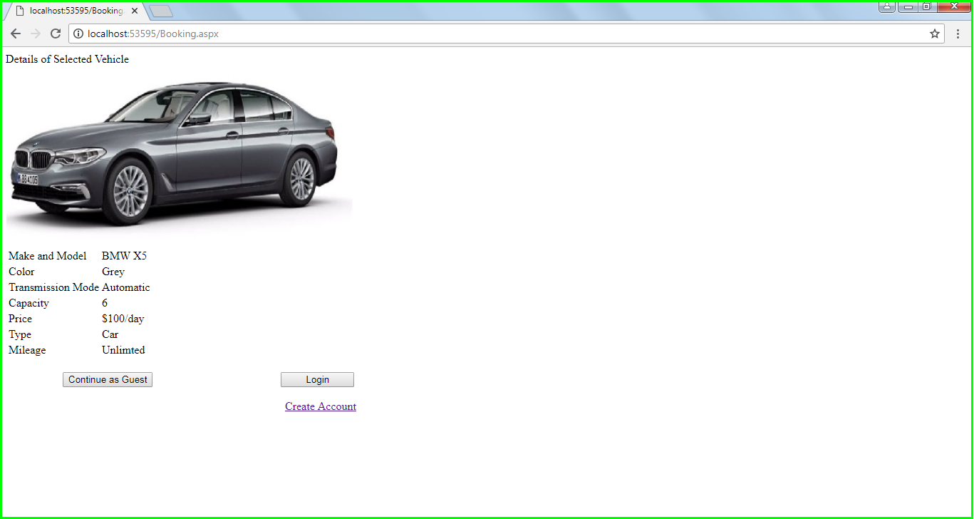

* User views all the car specifics and information
* User can either continue as a guest or create account
* User can also login

1. Register

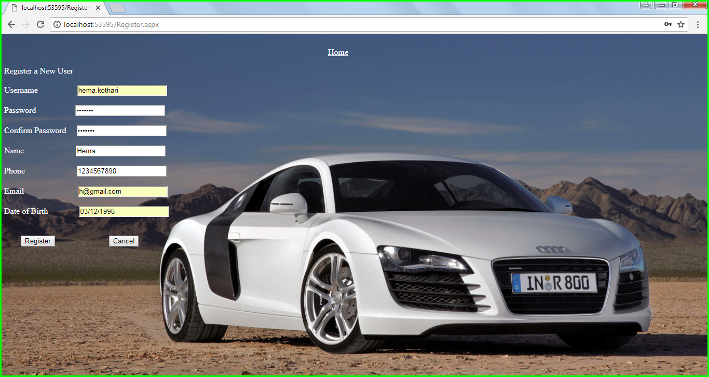

* User can register by entering all the details
* User selects register
* The User is registered

1. Admin/User Login

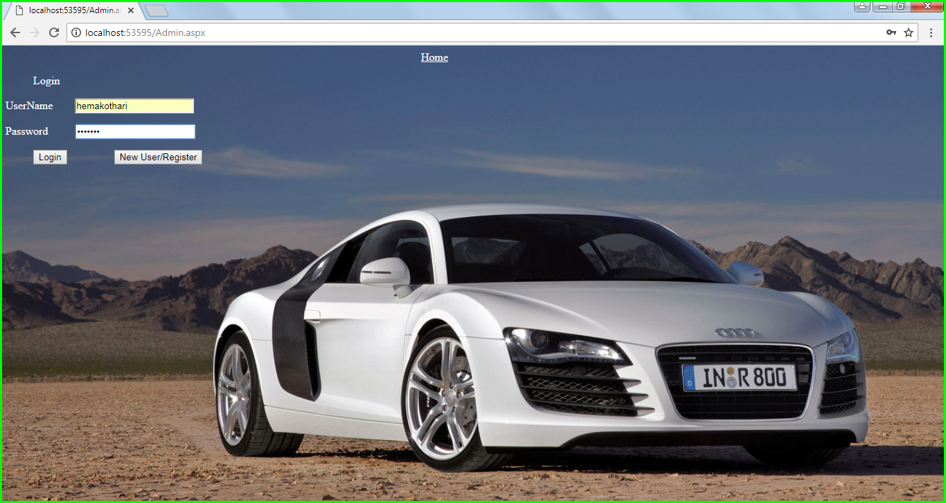

* User can login by enterning Username and password
* User can select login
* User can use New User/Register option to register a new account

1. Review (Continue as Guest option)

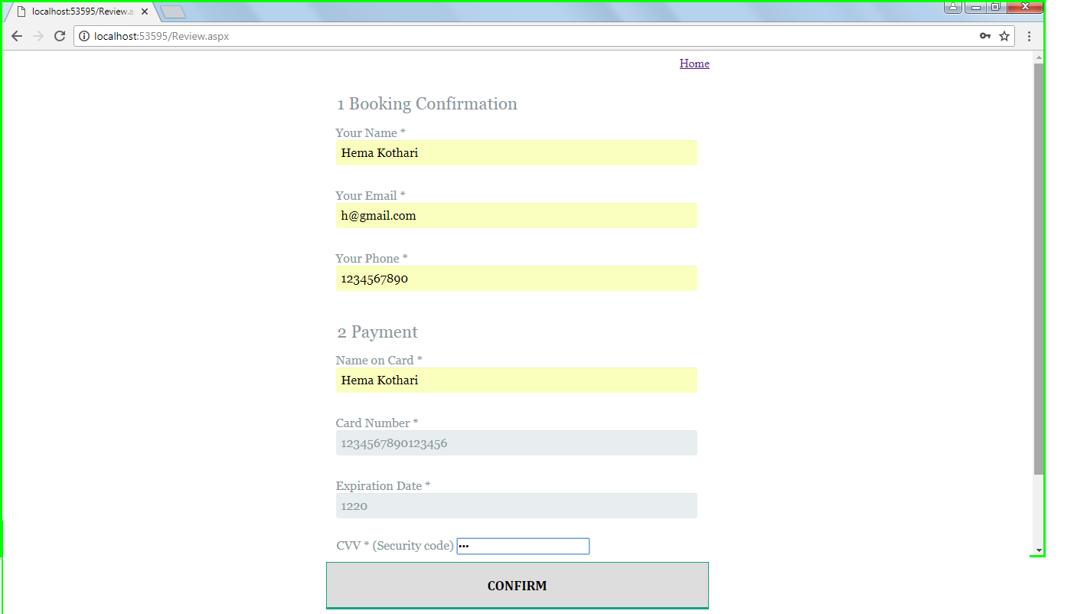

* User should enter name,email, phone number
* User should enter payment details (Card details).
* User should select confirm option.

1. Payment (Continue after Logging in)

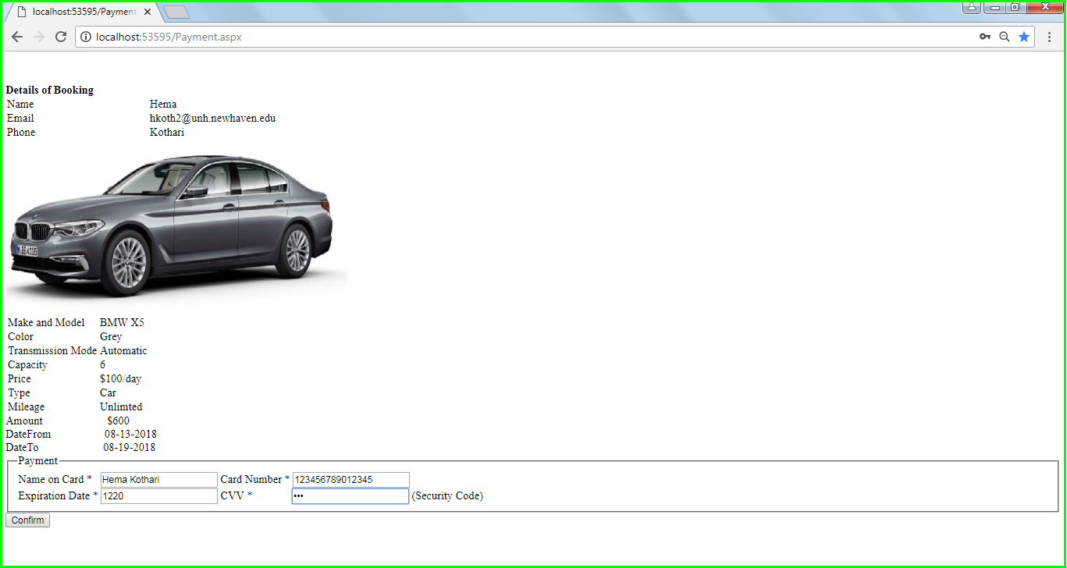

* User should enter payment details (Name on card, card number, Expiration date,Cvv)
* User selects confirm.

1. Confirmation

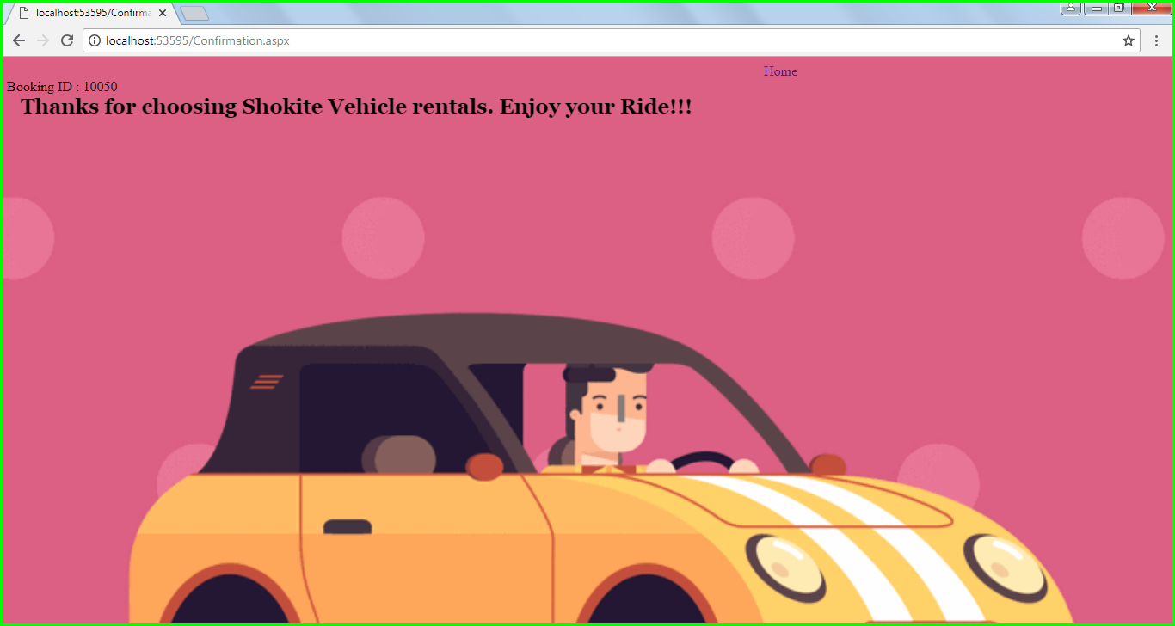

* User has finished booking vehicle.
* User can view the Booking ID

1. View Booking

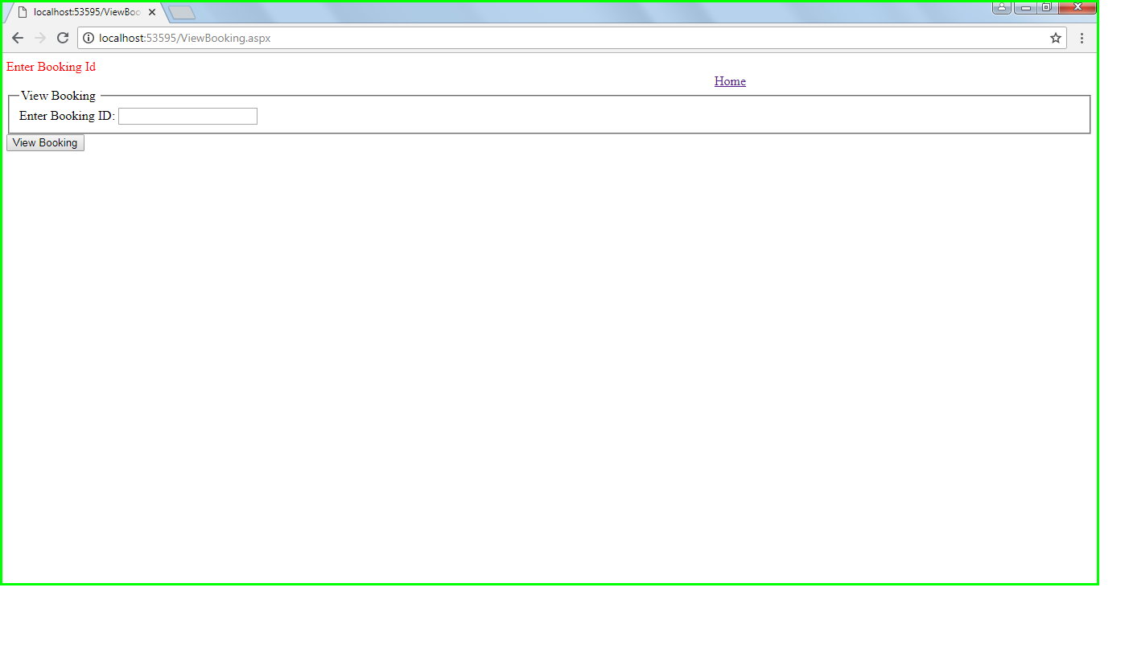

* User can enter Booking ID
* User selects view booking

1. View booking

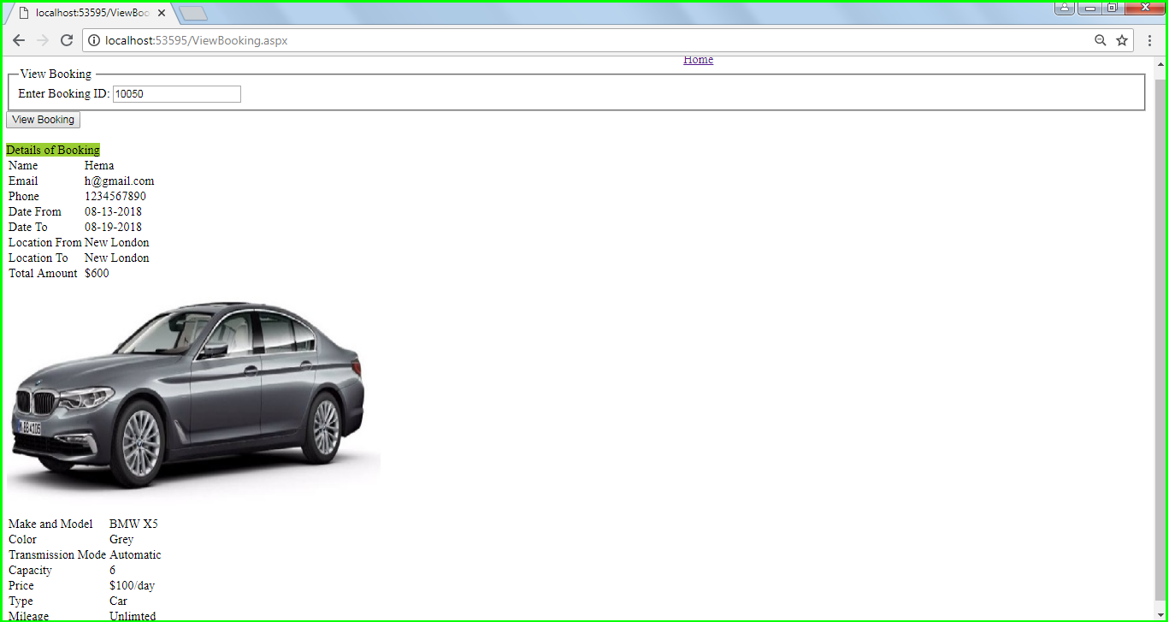

* The booking information is displayed
* The User can view booking details

1. Main (Add vehicle)

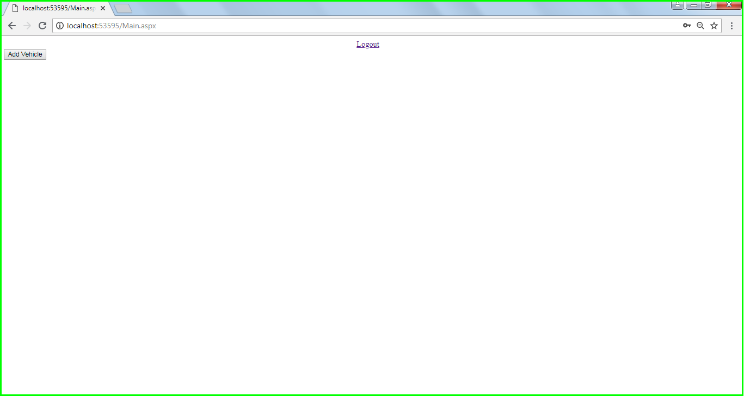

* Administrator can select add vehicles option to add vehicles.

1. Main(Add vehicles to Database)

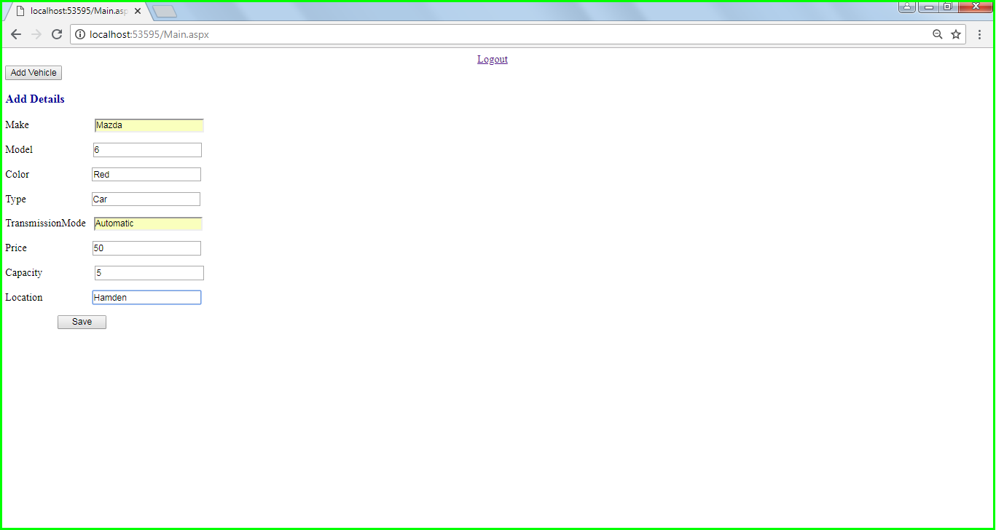

* Administrator can add vehicle details (Make,model,color,type,transmission,price,capacity and location).
* Administrator saves the details to database

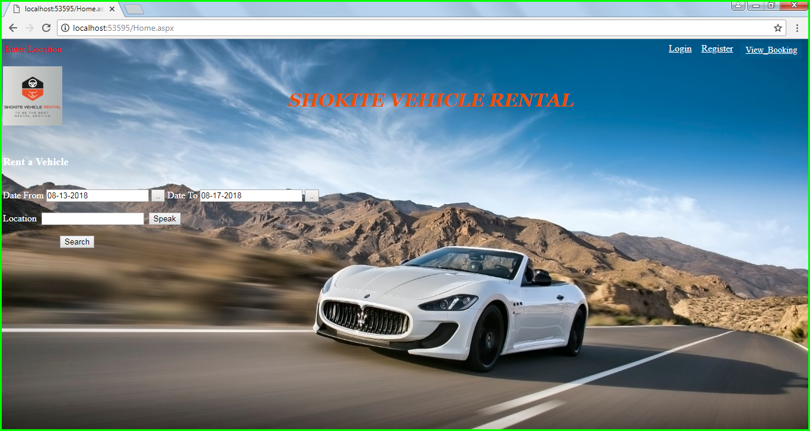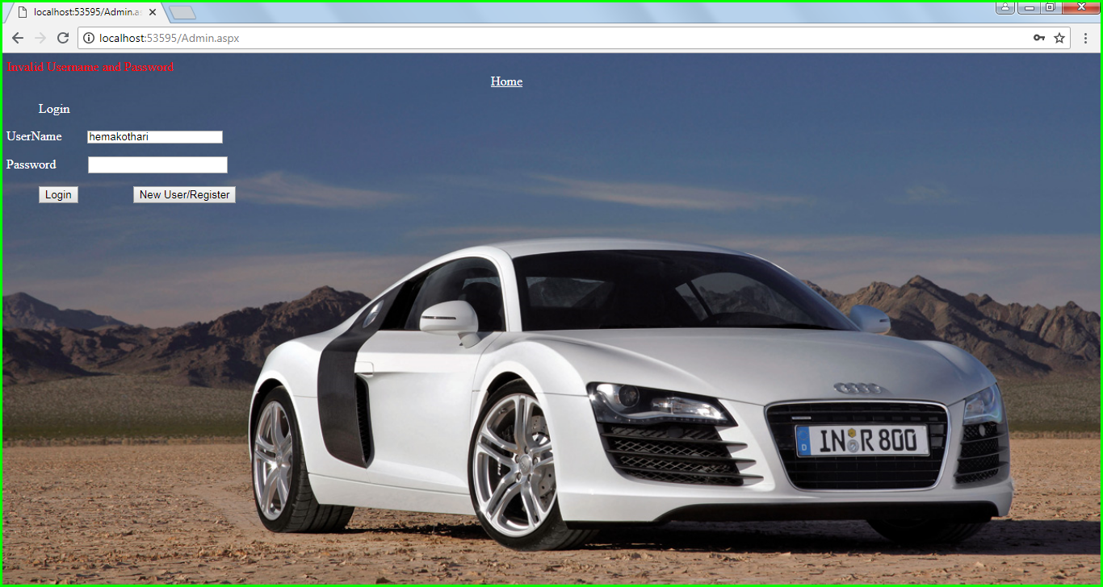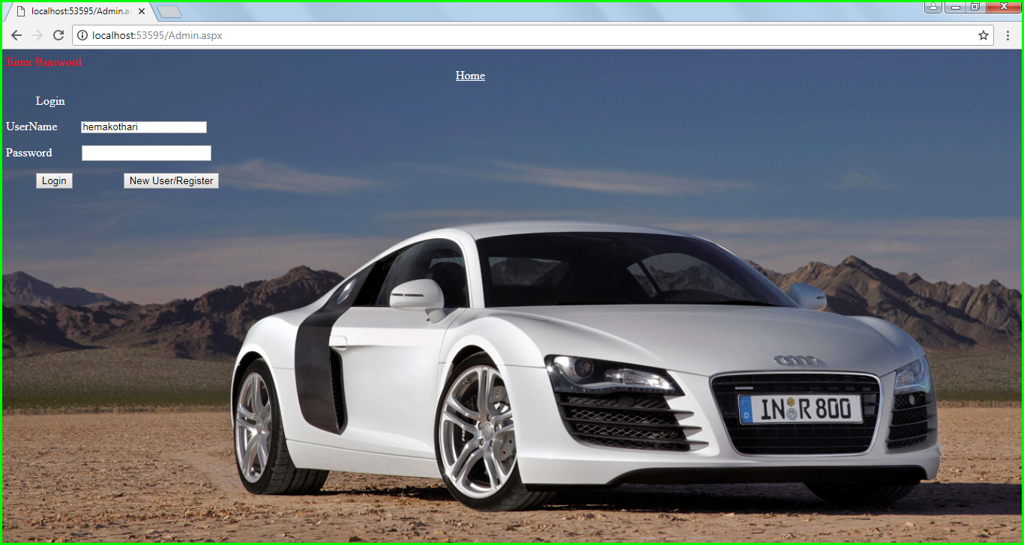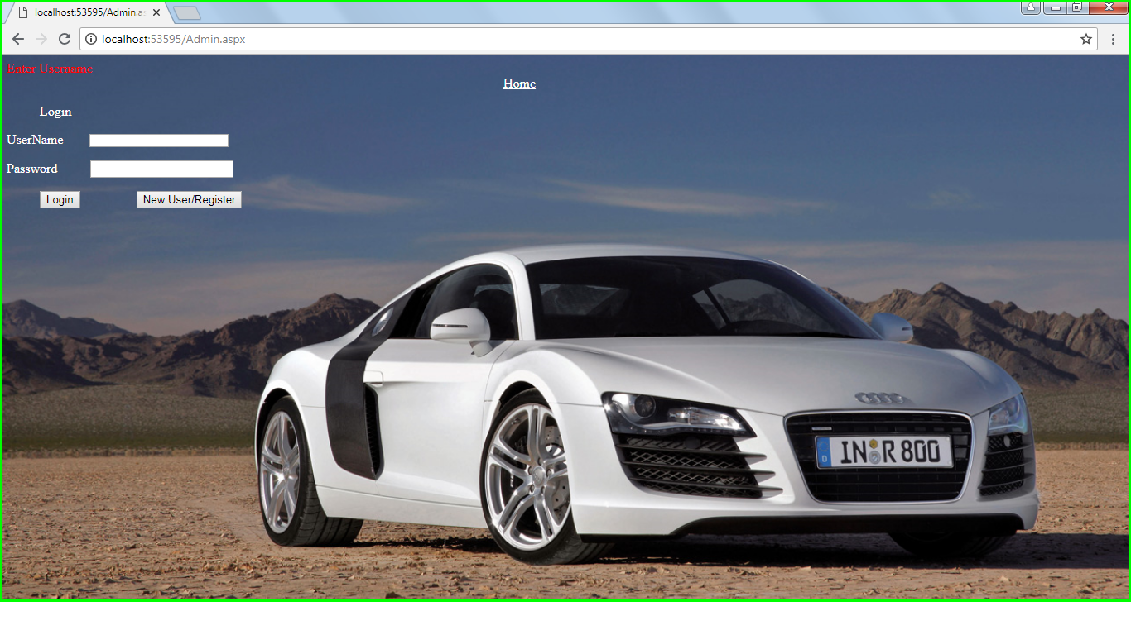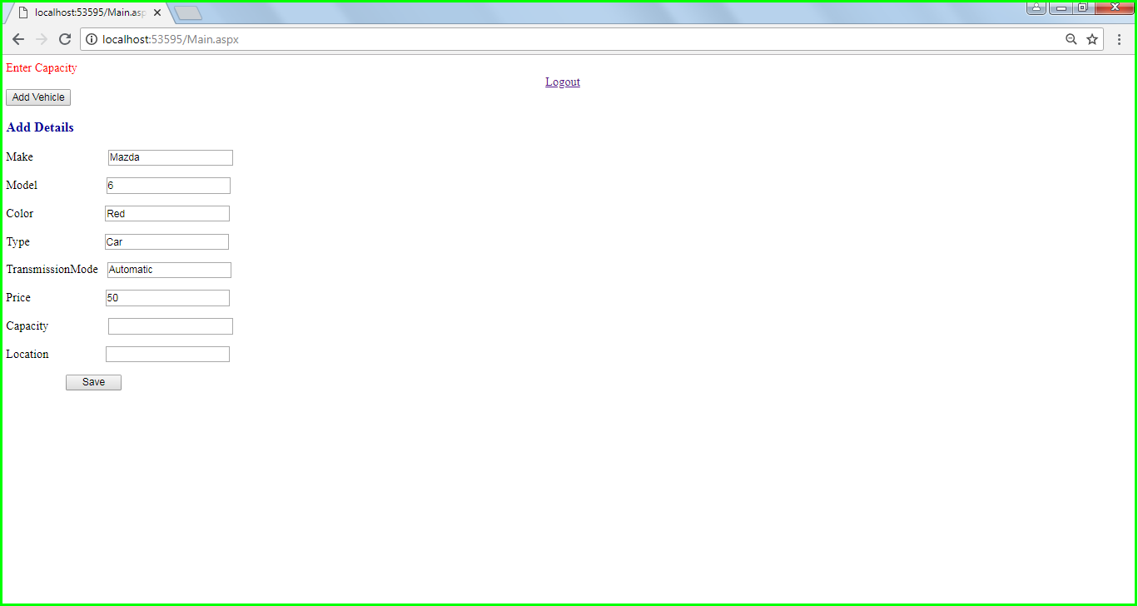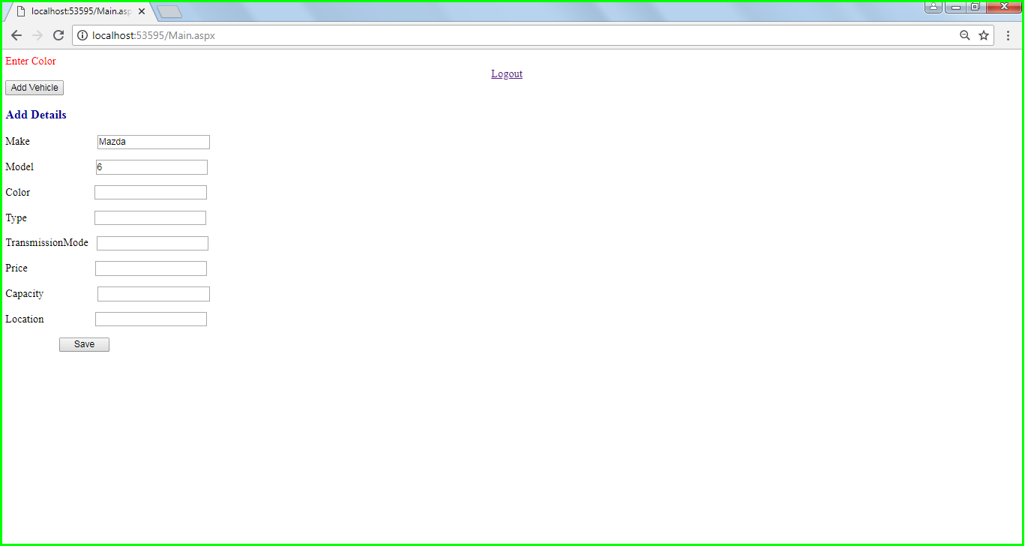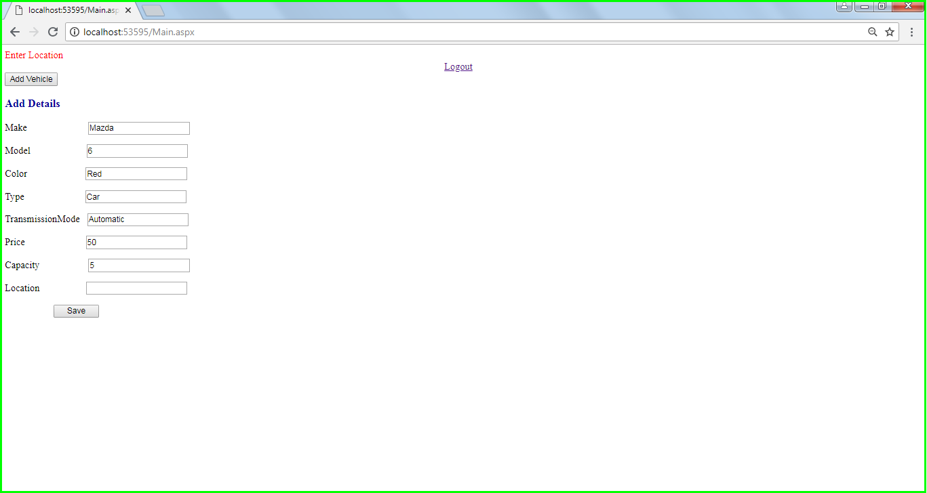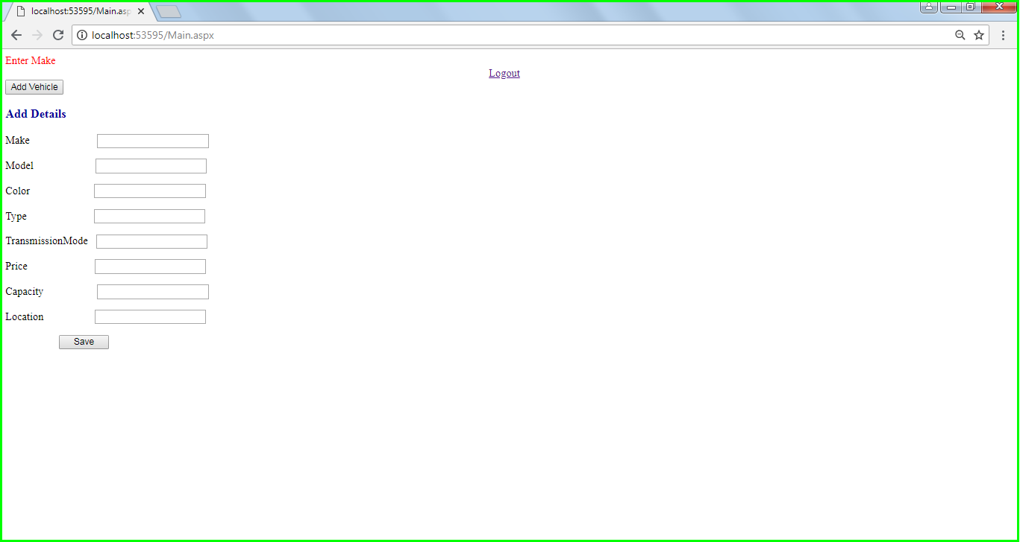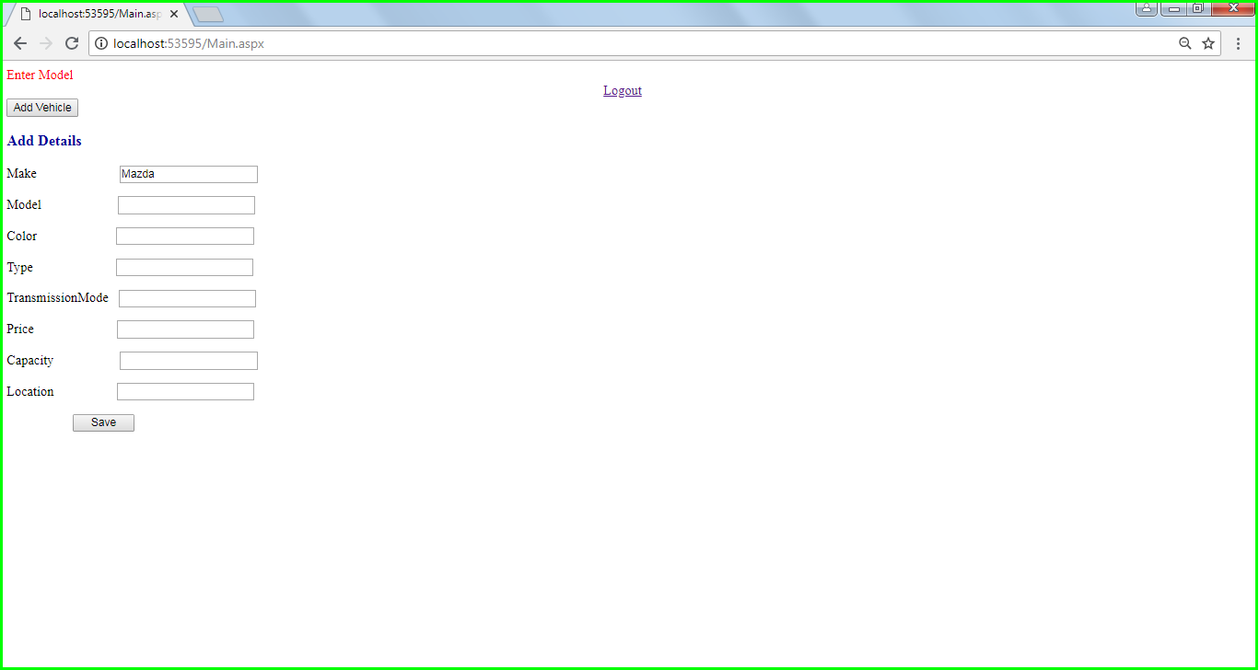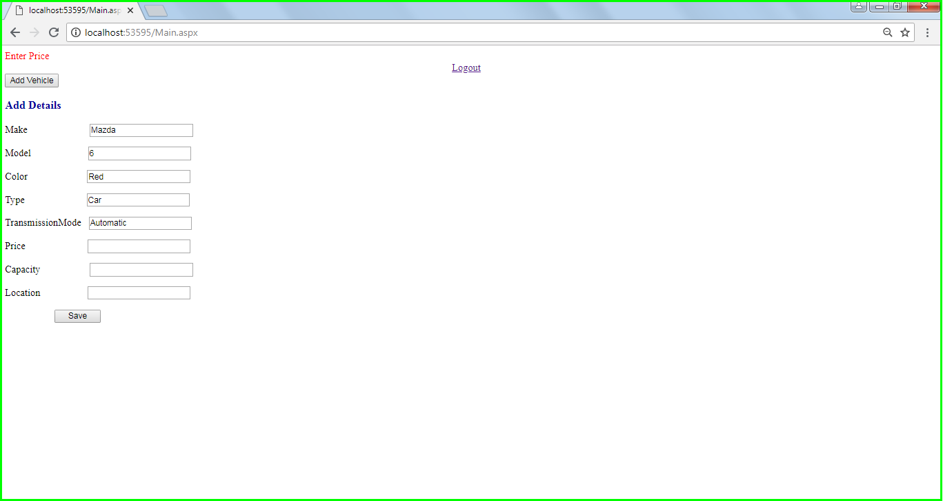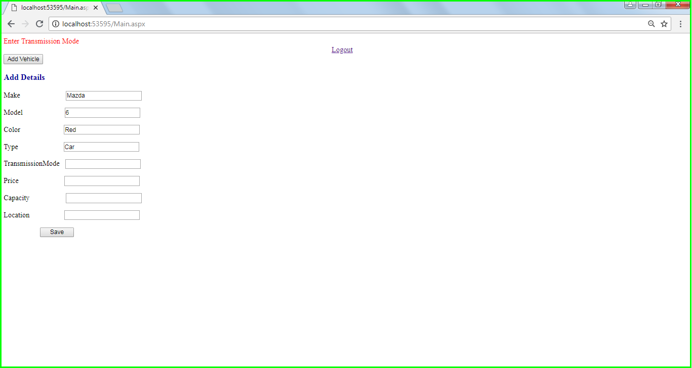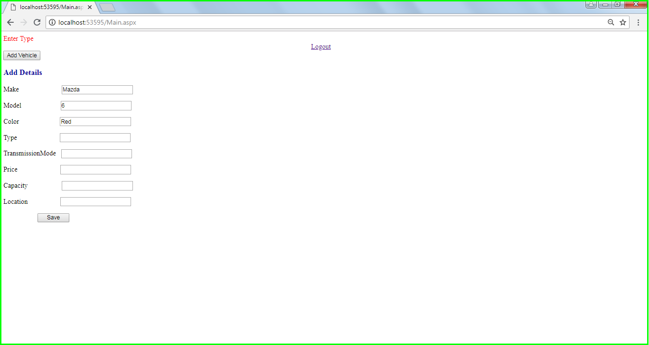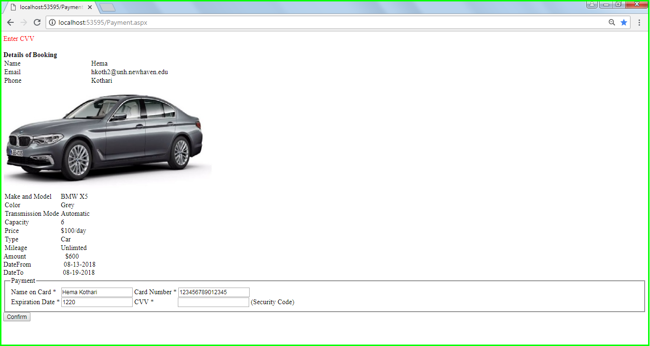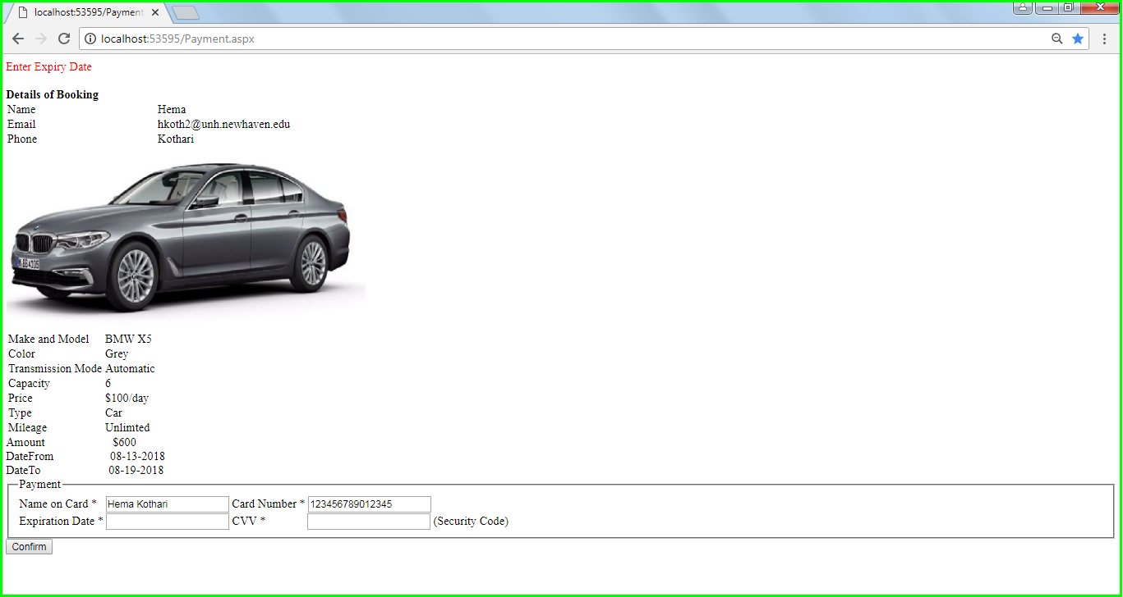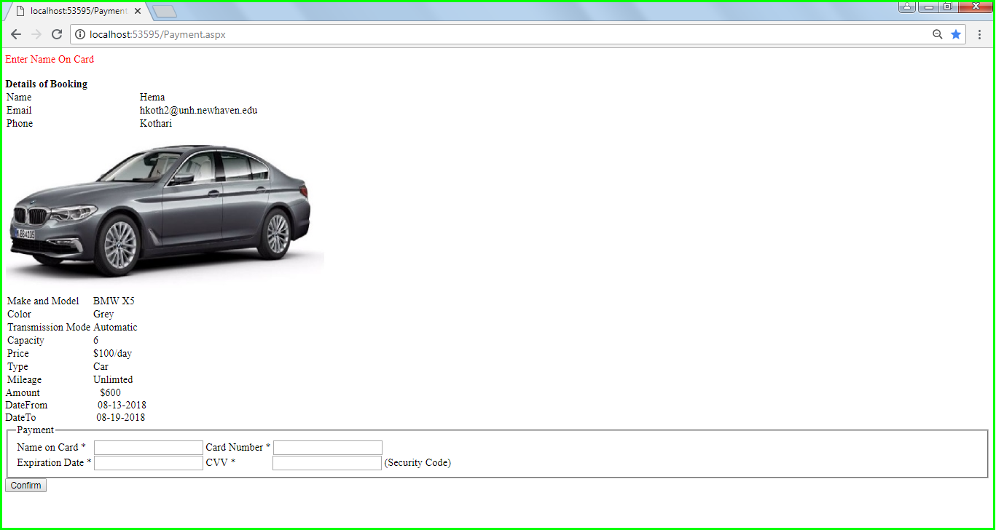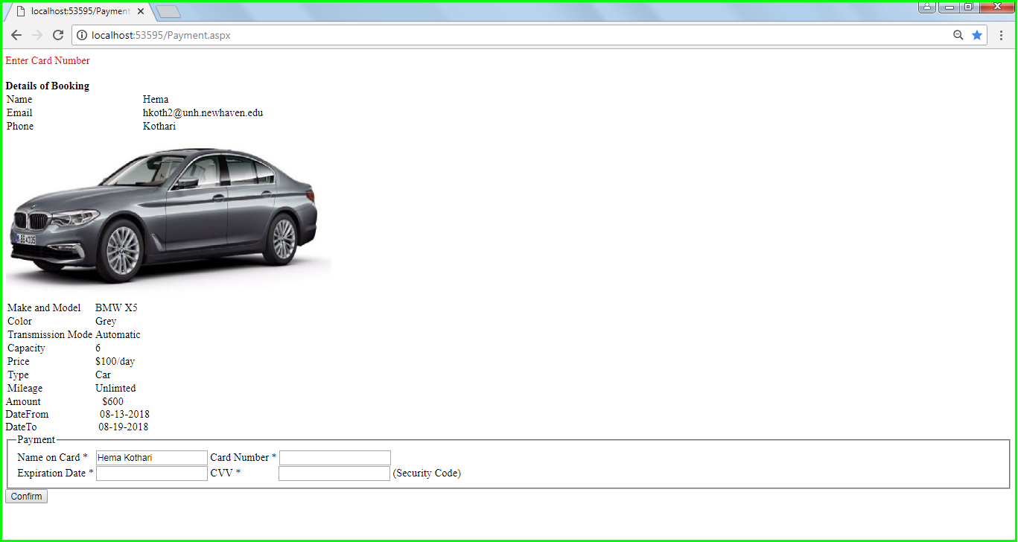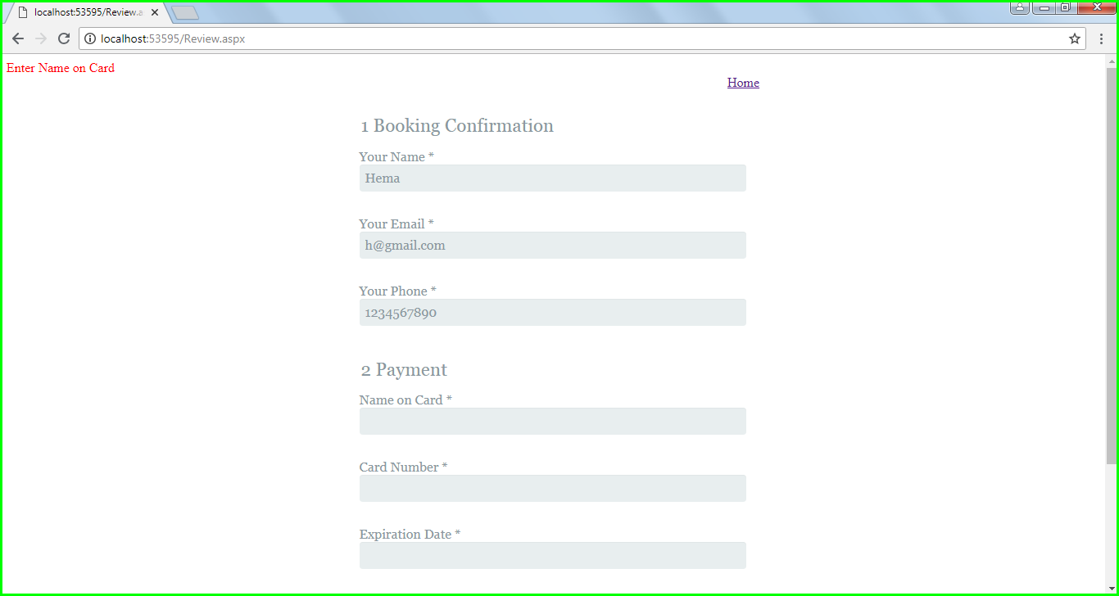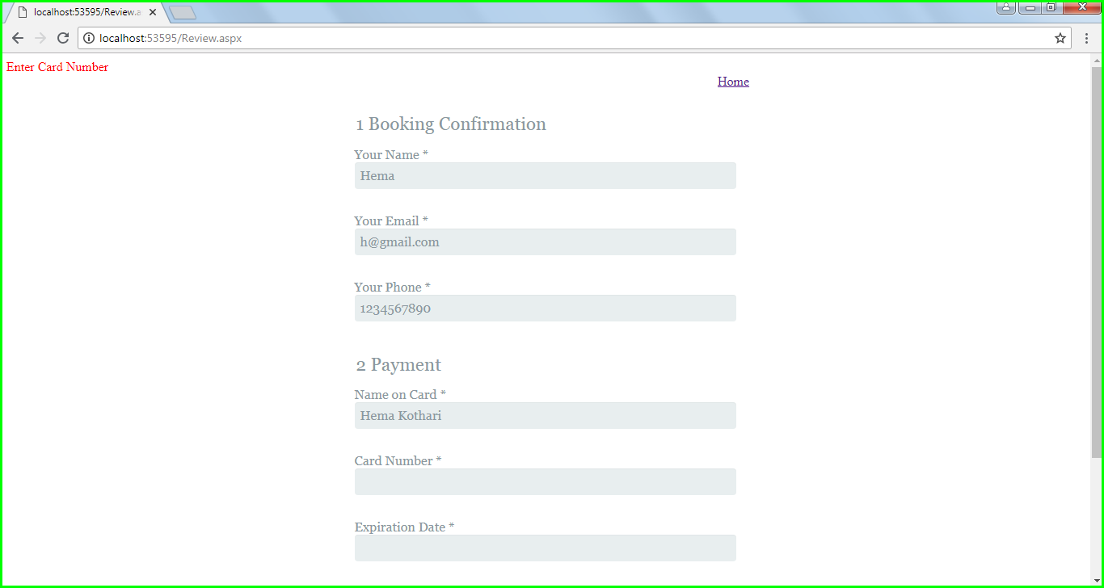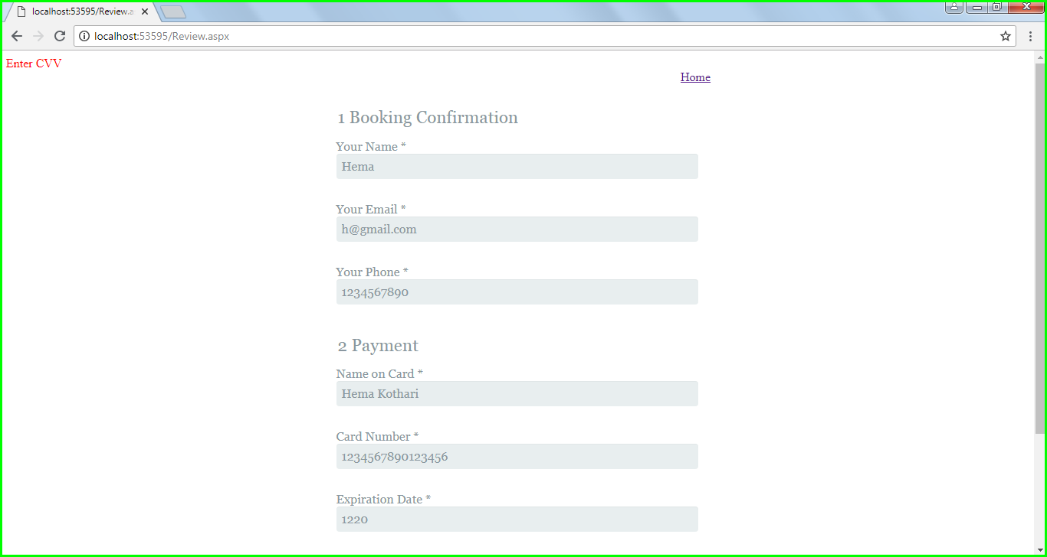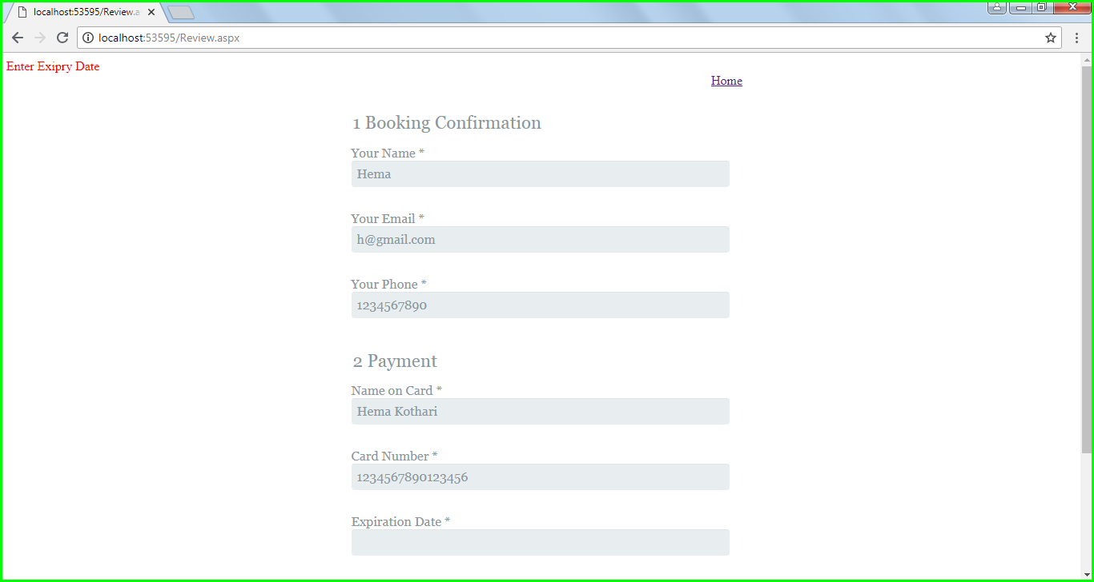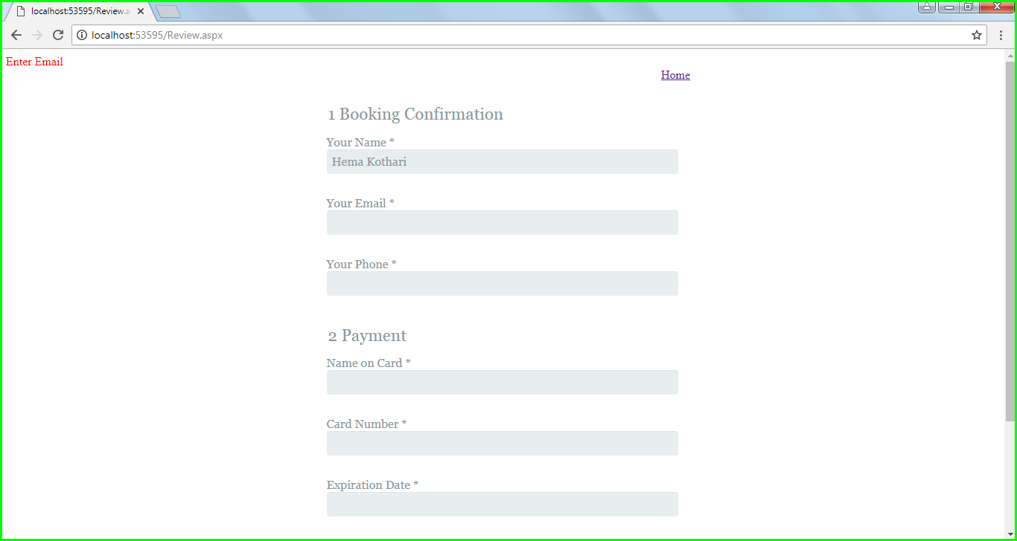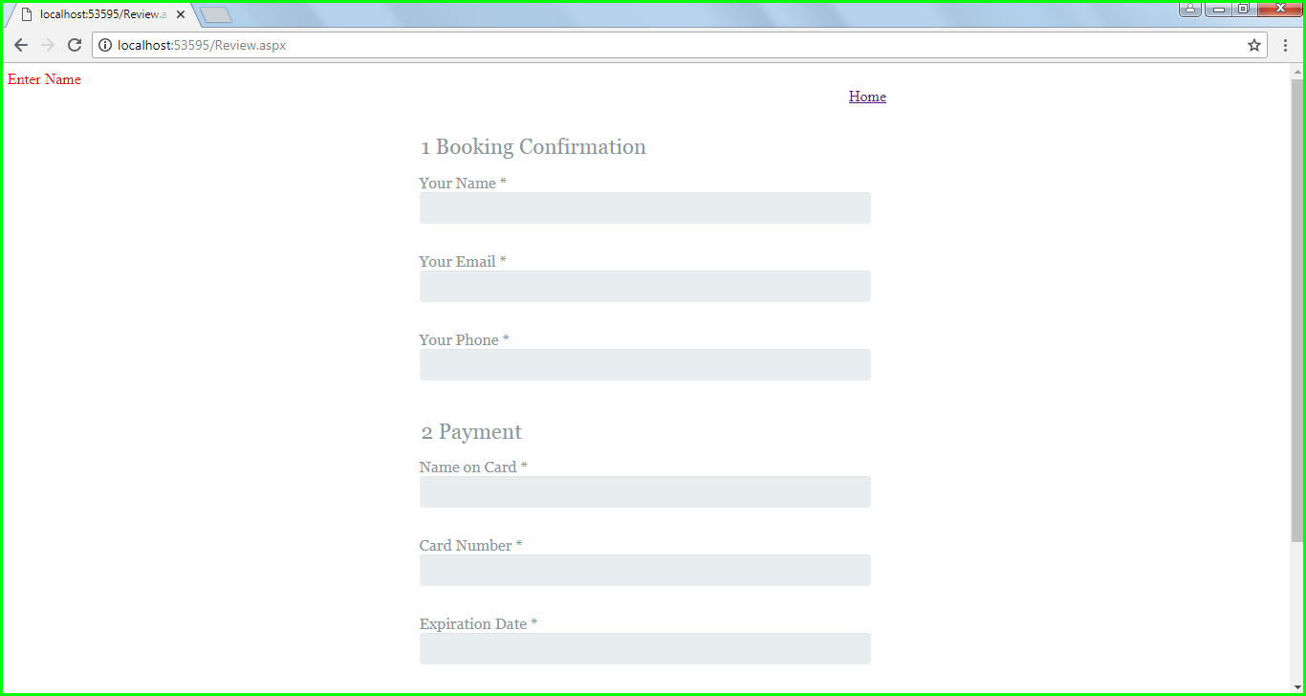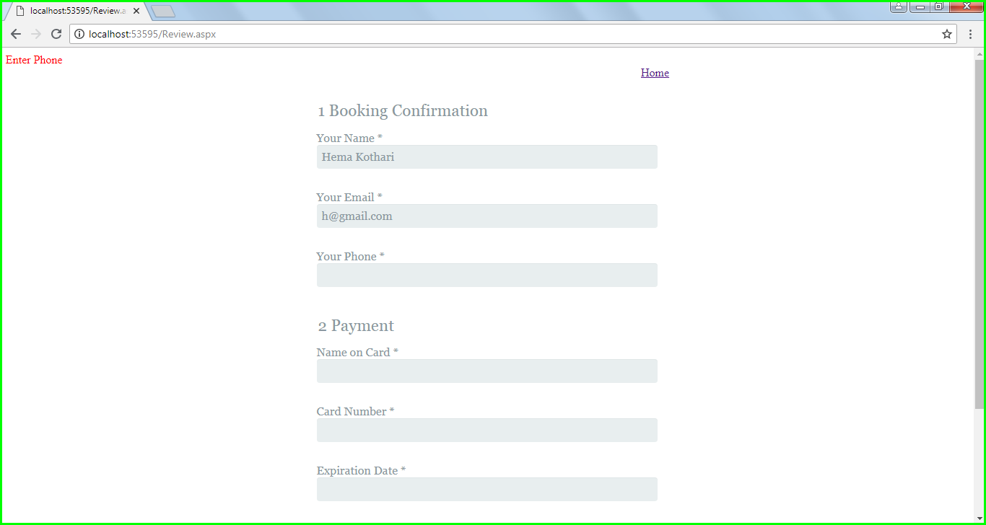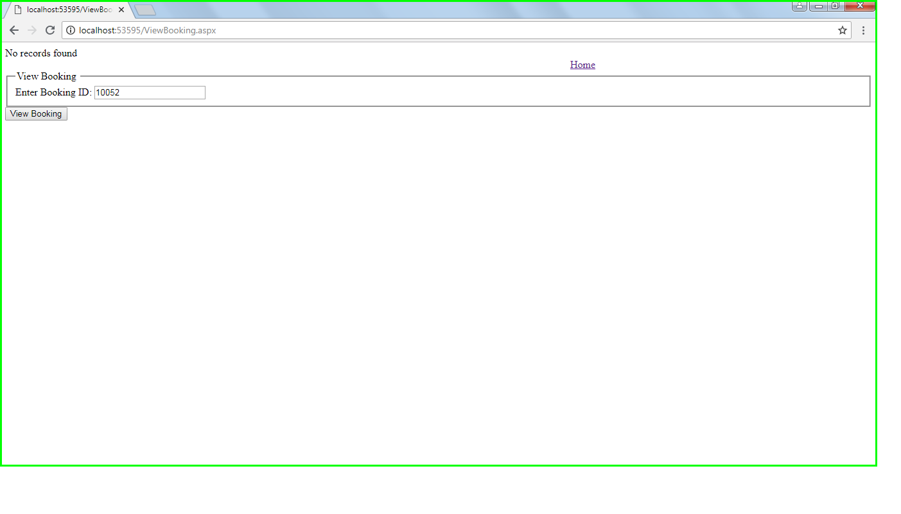

# 5. USER GUIDE

1. Home Page and Search Vehicle:

* Select the start date and end date
* Enter the user’s current location or the location where the user wants to pick his/her Vehicle.

1. List of Vehicles

* The List of Vehicles available at that location is display
* User scrolls down the list and selects a vehicle of his/her choice
* The User then books the vehicle

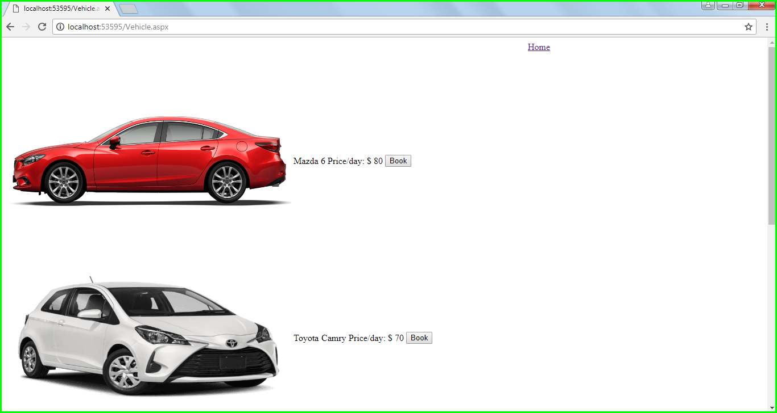

1. Administrator Login

* Administrator Logs In using the administrator credentials
* The Administrator then selects Login button

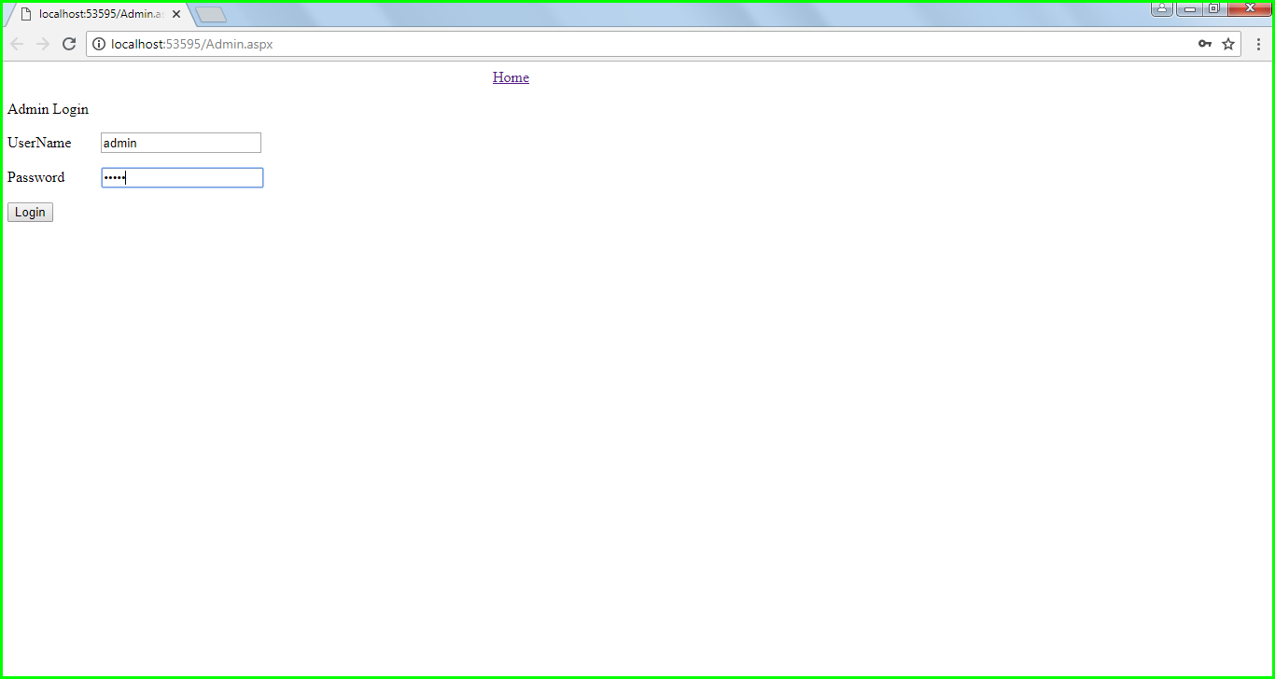

1. Add Vehicle Details

* Administrator Fills out all the information about the vehicle asked in the page below
* After entering the vehicle details the Administrator saves the data in a database

# 6. PROGRAM

### 6.1 Program Code (Java)

1. HomePage

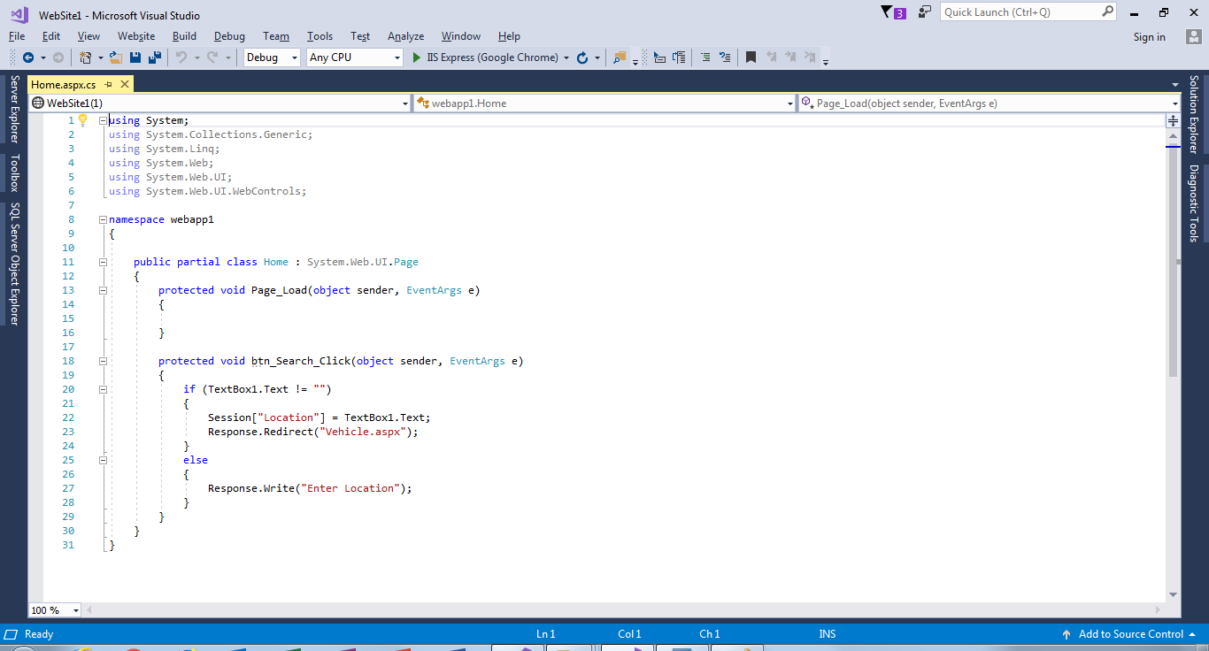

1. List Vehicle Page Source Code

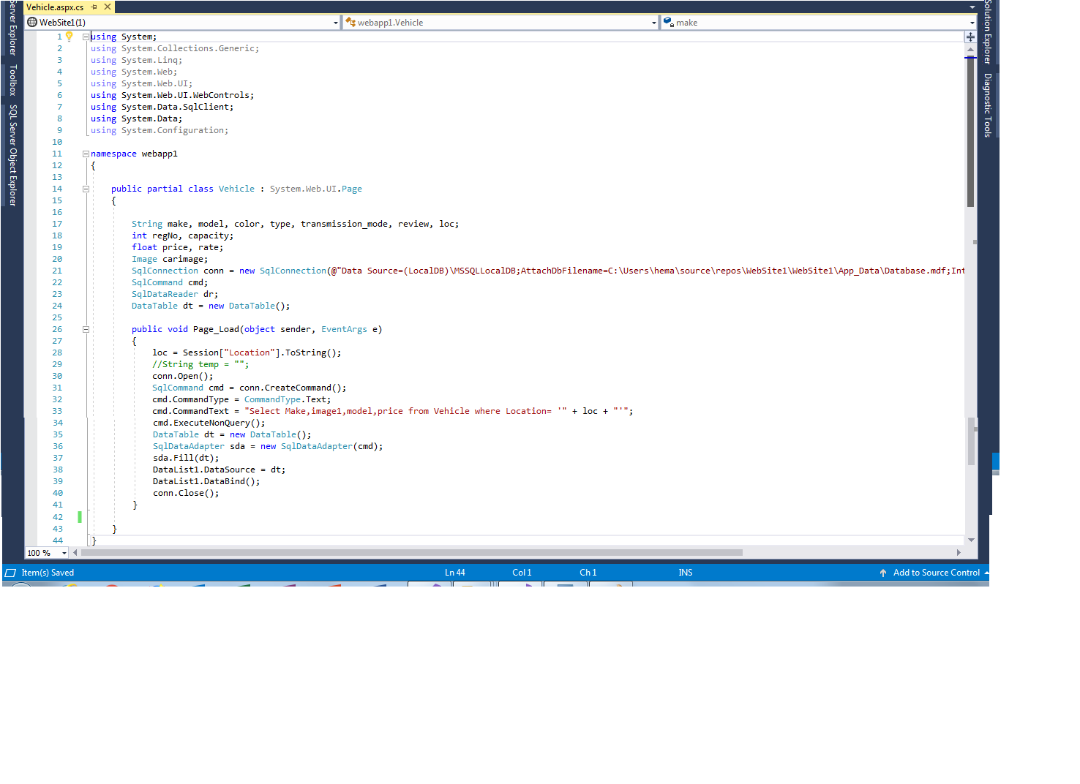

1. Admin Login Page Source Code

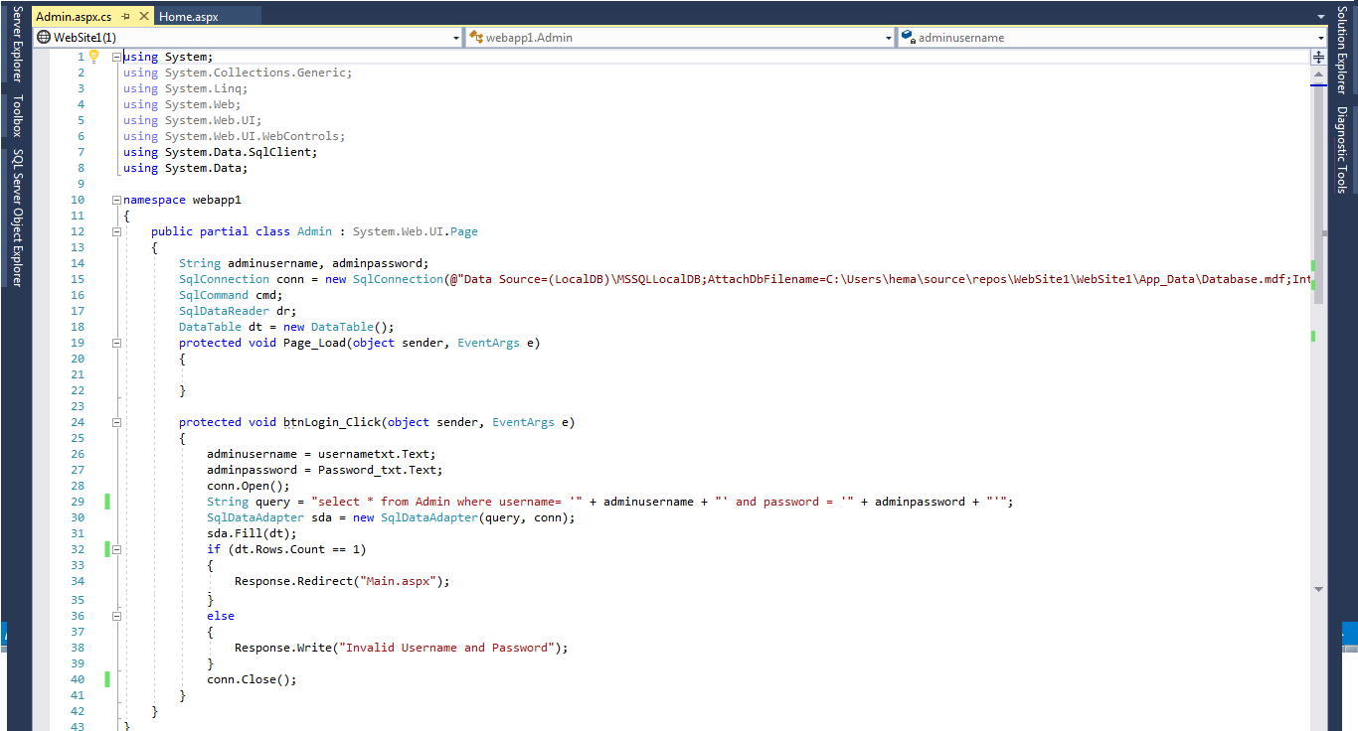

1. Add Vehicle Source Code

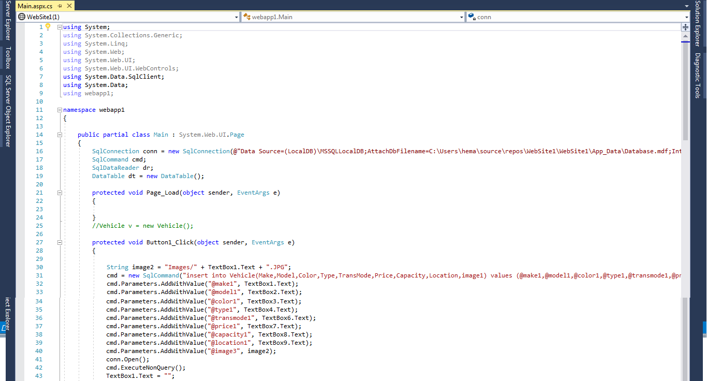

### 6.4 Testing Documentation

#### 6.4.1 Testing Plan or Unit, Systems and Acceptance Testing

**Test Cases:**

* + - 1. **Admin**

**1.1**

* + - 1. **Main**
      2. **Register**
  1. **Enter Username**

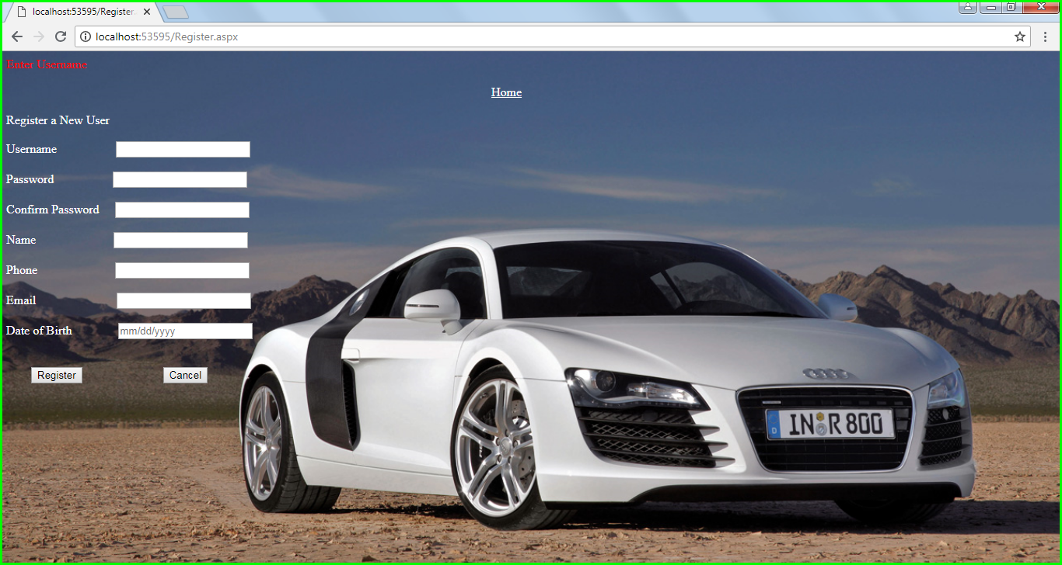

* 1. **Enter Password**

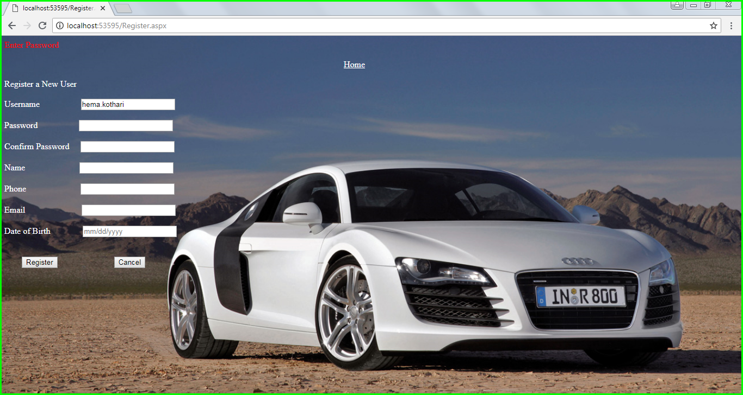

* 1. **Confirm Password**

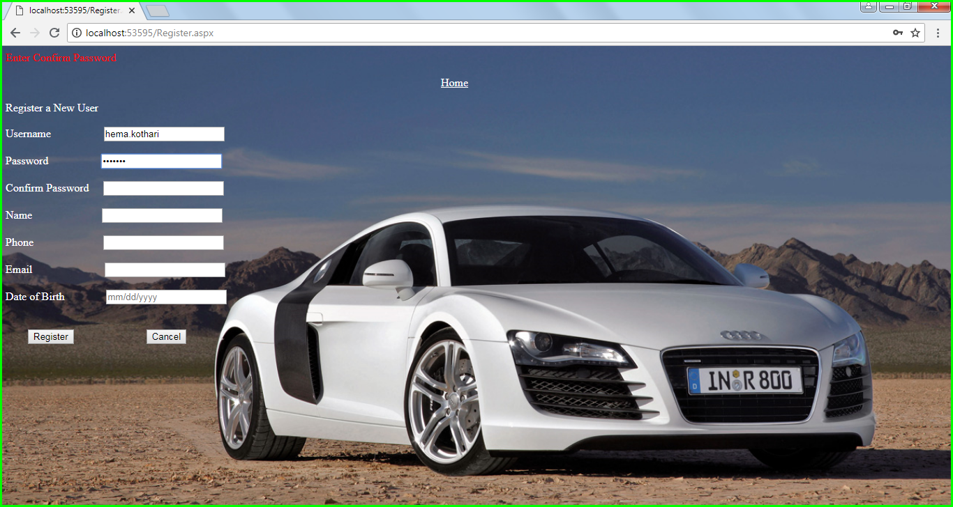

* 1. **Enter Name**

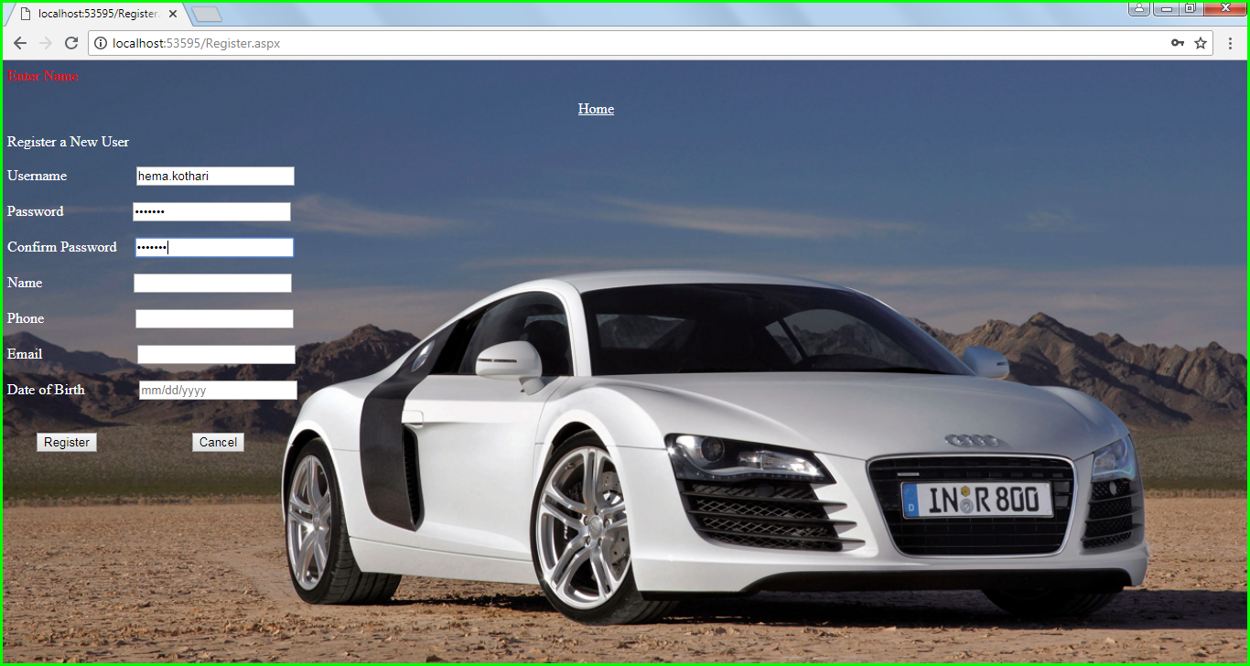

* 1. **Enter Phone**

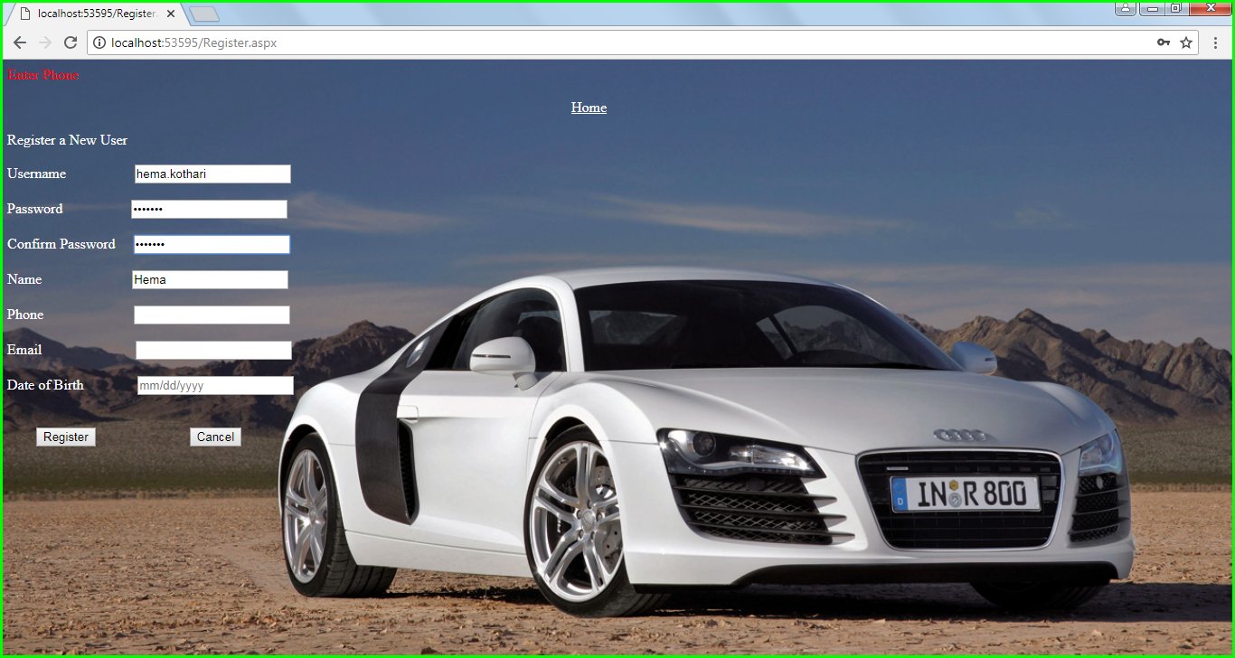

* 1. **Email**

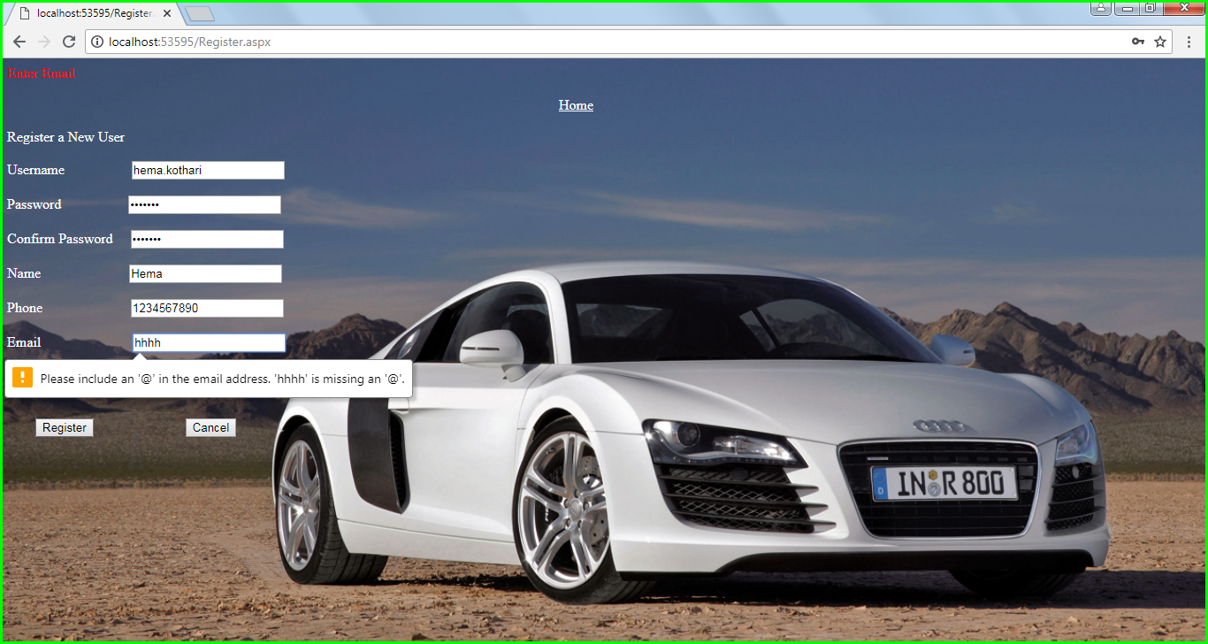

* 1. **Date of Birth**

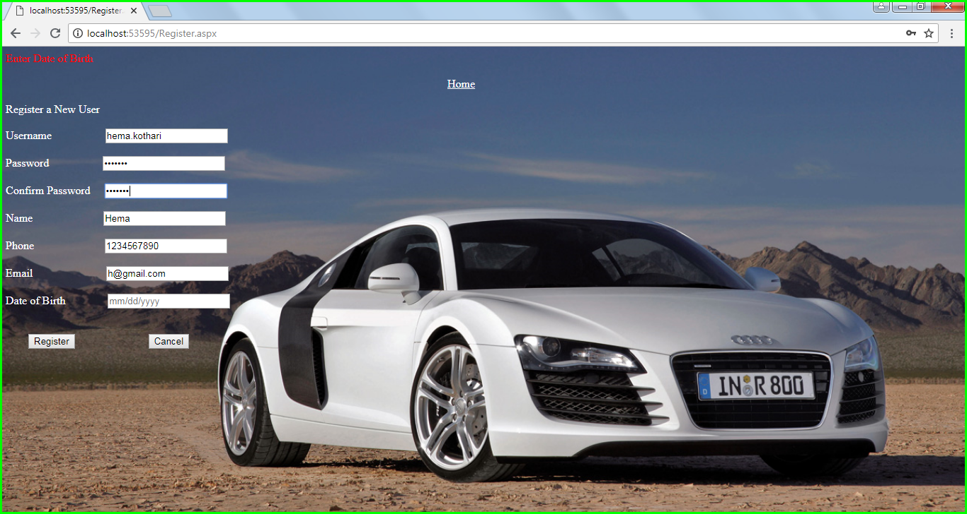

* + - 1. **Home**
      2. **Vehicle**
      3. **Booking**
      4. **Payment**
      5. **Confirmation**
      6. **ViewBooking**

**1.1 Date from**

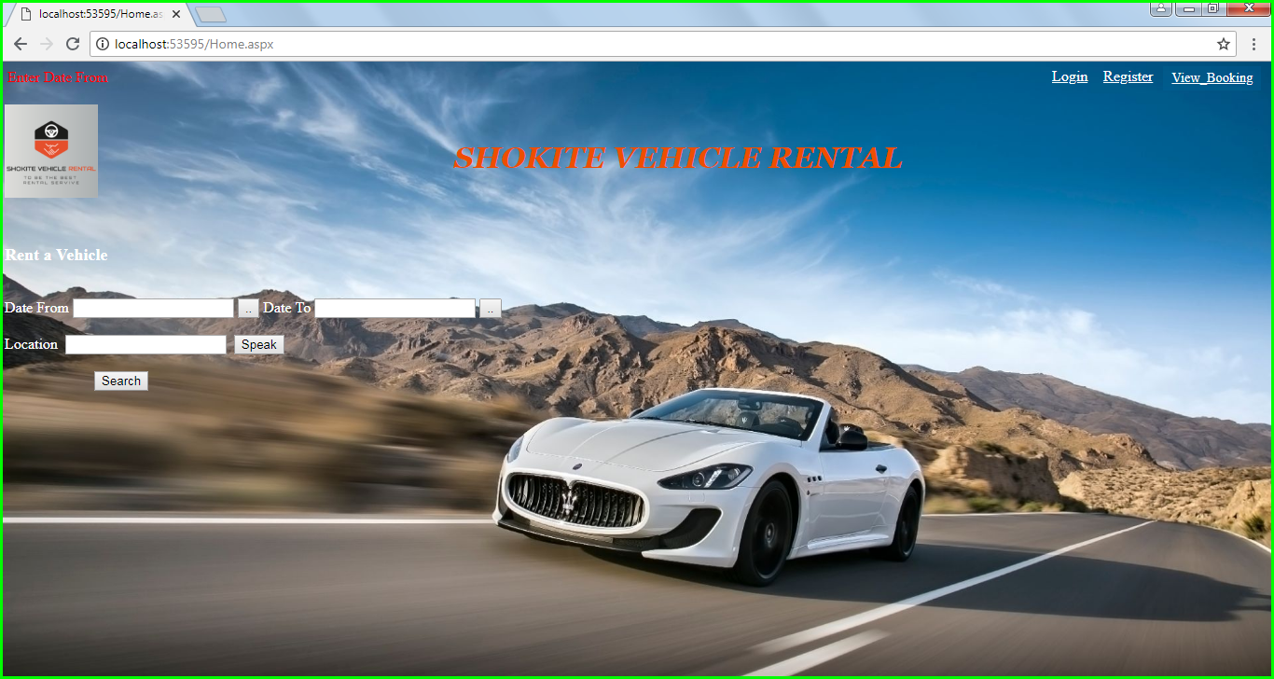

**1.2 Enter date to**

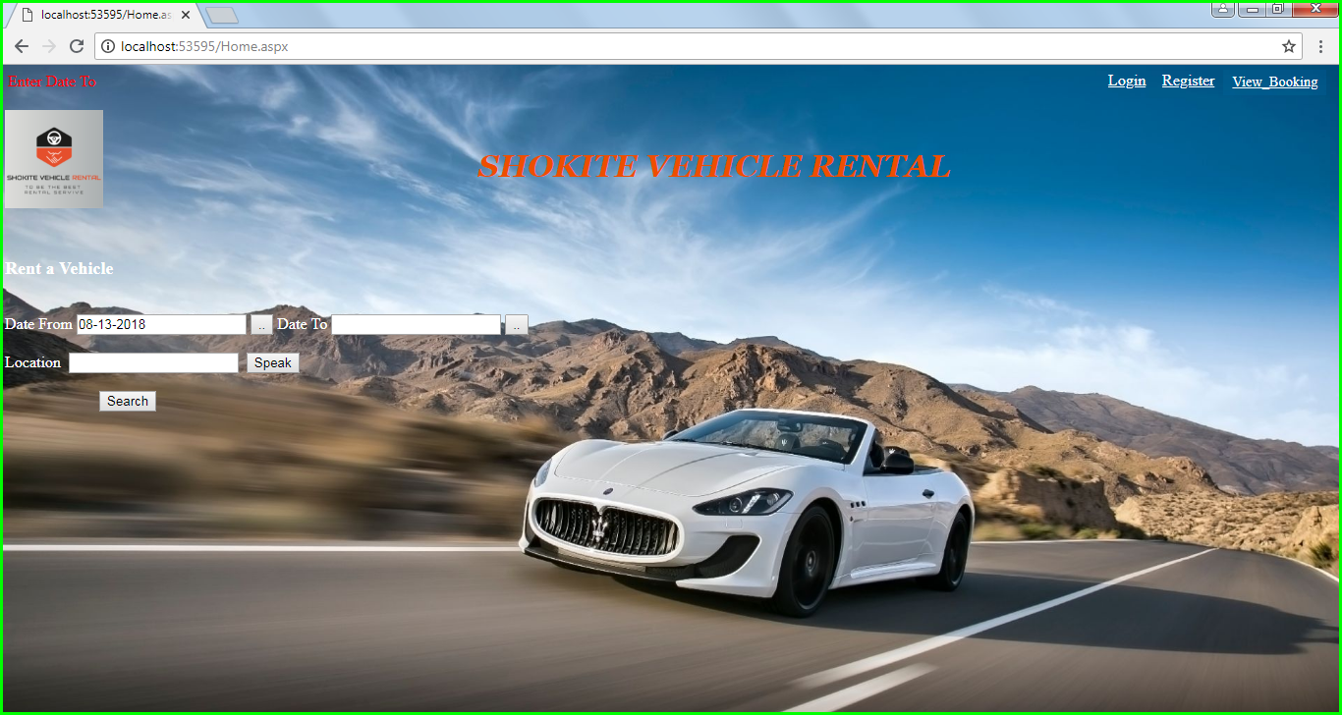

**1.3 Enter Location**

|  |  |
| --- | --- |
| **Test Case 1** | |
| **Test Case Name:** | In Home Screen, Location not entered |
| **Description:** | If location is not entered, will show error message. |
| **Output:** | Display validation Controller message in browser “Enter Location” |

|  |  |
| --- | --- |
| **Test Case 2** | |
| **Test Case Name:** | On Admin Login Screen, verify Admin Credentials |
| **Description:** | If incorrect credentials, will show error message |
| **Output:** | Display validation Controller message in browser “Invalid Username and Password” |

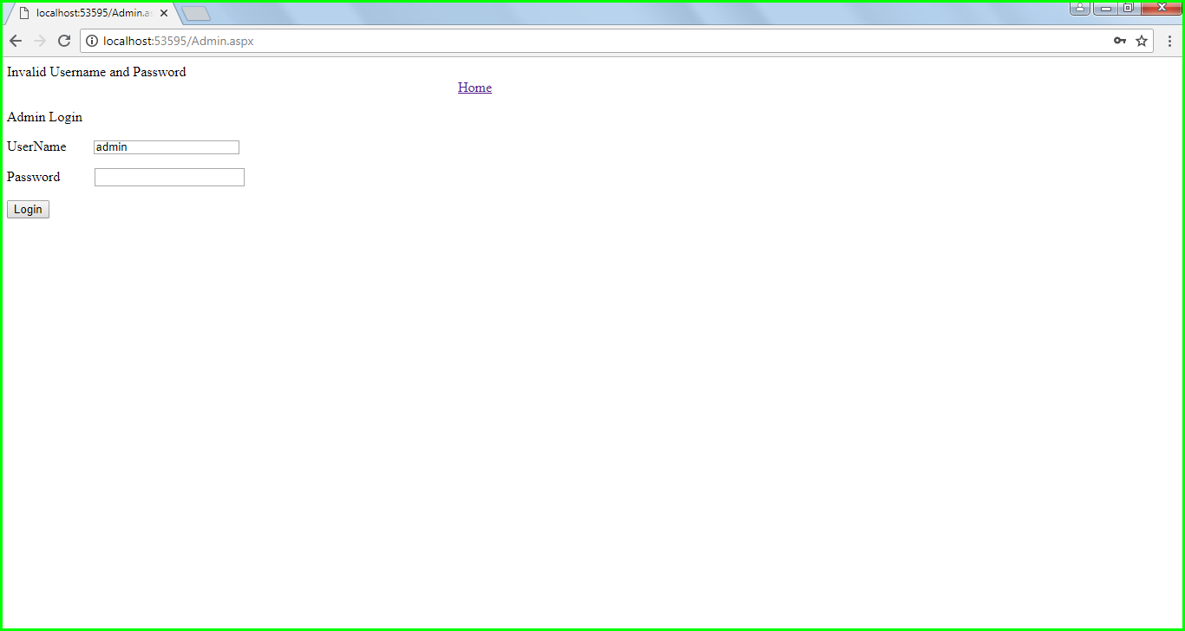

6.4.2 Screen Shots of GUI for testing plan

# 7. REFLECTION

### 7.1 What worked well

* Co-ordination between project members was good.
* Work was distributed well, and no one was much overloaded.
* Task allocated were worked on defined timelines.

### 7.2 What didn’t work well

* Lot of time was spent in Research.
* There was rework for some of the diagrams because of some minor glitches.

### 7.3 Lessons learned

* Spent extended hours to cover research and rework time, so we must make sure that things are done straight at first place.
* Learned different types of diagrams and how project works in real world

### 7.4 Impact on project

* Could have worked on more User Stories compared to what we worked now.

# 8. APPENDICES

* 1. Invoice Check with prof

|  |  |
| --- | --- |
| Documentation | Hema – 96, Mounika – 96, Rishi – 96 |
| Research | Hema – 96, Mounika – 96, Rishi – 96 |
| Design | Hema – 20, Mounika – 30, Rishi – 22 |
| Code | Hema – 79, Mounika – 70, Rishi – 72 |
| Testing | Hema – 2, Mounika – 1, Rishi – 1 |

### Reliable Estimate for remaining work of the project - based on remaining Use Cases

### **Use cases for the next Phase**

Please Refer use cases below for next phase

* + 1. Filter on Average Customer Rating
    2. Vehicle Pick-up Locations
    3. Drop Vehicle at Home
    4. Receipt of booked Vehicle
    5. Adding Additional Drivers with insurance
    6. Printing receipt of booked vehicle
    7. Upgrade an existing booking
    8. Assign privileges to Customer
    9. Modify future booking
    10. Cancel future booking
    11. Provide Insurance details
    12. View Terms and Conditions
    13. Choose a language
    14. Rent a vehicle for long term
    15. View reward points
    16. Rate and Review
    17. Choose Additional Accessories
    18. Pick up and Drop off Location
    19. Access to Reports
    20. View Special Rates
    21. Manage Memberships
    22. Access to Driving Records
    23. Redeem Reward Points
    24. Navigate Pick Up Location
    25. Access to customer benefits
    26. Provide Promotions, Membership rewards points, Family benefits
    27. Administrator Should Provide Proper Encryption
    28. Choose calendar day
    29. Customize Payments
    30. Payment through PayPal

### 8.4 Tools Used

* + 1. Software used for this system - ASP.Net, SQL Server, Visual Studio
    2. Software used to produce your documentation – Microsoft Word and PowerPoint
    3. Any other technology used to build this system - https://www.draw.io/